PLATCOV Statistical Analysis

James Watson

03 June, 2022

Table of Contents

TODO list:

* Flow diagram output

## Preambule

This is the analysis of the Ivermectin arm of the PLATCOV study

Data preparation is done in a different R script called data_prep.R. This Markdown script assumes that the data are saved in a .csv file *interim_dat.csv* in long format. The file *interim_dat.csv* contains the patient clinical and viral load data with the following column headers:

* ID: anonymised patient id code
* Time: time from randomisation
* Trt: treatment allocation as written in CRF
* Site: site at enrollment
* Timepoint_ID: Day of study (integer 0 to 14)
* BARCODE: unique sample id code (in the following format: PLT-site-number-swab type-timepoint)
* Swab_ID: RTS or TSL (right versus left tonsil)
* Plate: unique Plate ID for the PCR assay (matching with plate identifiers in interim_control_dat.csv)
* Rand_date: date of randomisation
* Any_dose: (0/1) any doses of any manufacturer received
* N_dose: integer number of doses received (any manufacturer)
* Antibody_test: 0/1 (negative/positive for SARS-CoV-2 antibody rapid test)
* Weight (kg)
* BMI: kg/weight^2
* Age: (years - has to be between 18-50)
* Sex: 0/1 (male: 1; female/other: 0)
* Symptom_onset: time since onset of symptoms (days)
* Variant: variant of concern (using standard WHO terminology for the main lineages, reference will be the predominant variant in the dataset at the start of the study)
* CT_NS: observed CT value for the N/S gene
* CT_RNaseP: observed CT value for the human RNase P gene
* Per_protocol_sample: whether at the time of sampling the patient was still in per protocol with respect to drug dosing
* IgG: + IgG band on the LFT
* IgM: + IgM band on the LFT
* log10_viral_load: log10 number of viral copies per mL (estimated from control samples using a mixed effects model)
* log10_cens_vl: censoring value

## Computational setup

## _   
## platform x86_64-apple-darwin17.0   
## arch x86_64   
## os darwin17.0   
## system x86_64, darwin17.0   
## status   
## major 4   
## minor 0.2   
## year 2020   
## month 06   
## day 22   
## svn rev 78730   
## language R   
## version.string R version 4.0.2 (2020-06-22)  
## nickname Taking Off Again

## R version 4.0.2 (2020-06-22)  
## Platform: x86_64-apple-darwin17.0 (64-bit)  
## Running under: macOS 10.16  
##   
## Matrix products: default  
## BLAS: /Library/Frameworks/R.framework/Versions/4.0/Resources/lib/libRblas.dylib  
## LAPACK: /Library/Frameworks/R.framework/Versions/4.0/Resources/lib/libRlapack.dylib  
##   
## locale:  
## [1] en_GB.UTF-8/en_GB.UTF-8/en_GB.UTF-8/C/en_GB.UTF-8/en_GB.UTF-8  
##   
## attached base packages:  
## [1] stats graphics grDevices utils datasets methods base   
##   
## other attached packages:  
## [1] plotrix_3.8-2 dplyr_1.0.7 reshape2_1.4.4   
## [4] tictoc_1.0.1 censReg_0.5-32 maxLik_1.5-2   
## [7] miscTools_0.6-26 RColorBrewer_1.1-2 loo_2.4.1   
## [10] rstanarm_2.21.1 Rcpp_1.0.7 lme4_1.1-27.1   
## [13] Matrix_1.3-4 rstan_2.21.2 ggplot2_3.3.5   
## [16] StanHeaders_2.21.0-7  
##   
## loaded via a namespace (and not attached):  
## [1] plm_2.6-0 minqa_1.2.4 colorspace_2.0-2 ellipsis_0.3.2   
## [5] ggridges_0.5.3 rsconnect_0.8.24 markdown_1.1 base64enc_0.1-3   
## [9] rstudioapi_0.13 glmmML_1.1.1 DT_0.19 fansi_0.5.0   
## [13] codetools_0.2-18 splines_4.0.2 knitr_1.34 shinythemes_1.2.0   
## [17] bayesplot_1.8.1 Formula_1.2-4 jsonlite_1.7.2 nloptr_1.2.2.2   
## [21] shiny_1.6.0 compiler_4.0.2 backports_1.2.1 assertthat_0.2.1   
## [25] fastmap_1.1.0 cli_3.0.1 later_1.3.0 htmltools_0.5.2   
## [29] prettyunits_1.1.1 tools_4.0.2 igraph_1.2.6 gtable_0.3.0   
## [33] glue_1.4.2 V8_3.4.2 vctrs_0.3.8 nlme_3.1-153   
## [37] crosstalk_1.1.1 lmtest_0.9-38 xfun_0.26 stringr_1.4.0   
## [41] rbibutils_2.2.7 ps_1.6.0 collapse_1.7.6 mime_0.11   
## [45] miniUI_0.1.1.1 lifecycle_1.0.0 gtools_3.9.2 MASS_7.3-54   
## [49] zoo_1.8-9 scales_1.1.1 colourpicker_1.1.0 promises_1.2.0.1   
## [53] parallel_4.0.2 sandwich_3.0-1 inline_0.3.19 shinystan_2.5.0   
## [57] yaml_2.2.1 curl_4.3.2 gridExtra_2.3 bdsmatrix_1.3-4   
## [61] stringi_1.7.4 dygraphs_1.1.1.6 checkmate_2.0.0 boot_1.3-28   
## [65] pkgbuild_1.2.0 Rdpack_2.1.3 rlang_0.4.11 pkgconfig_2.0.3   
## [69] matrixStats_0.61.0 evaluate_0.14 lattice_0.20-44 purrr_0.3.4   
## [73] rstantools_2.1.1 htmlwidgets_1.5.4 processx_3.5.2 tidyselect_1.1.1   
## [77] plyr_1.8.6 magrittr_2.0.1 R6_2.5.1 generics_0.1.0   
## [81] DBI_1.1.1 pillar_1.6.2 withr_2.4.2 xts_0.12.1   
## [85] survival_3.2-13 tibble_3.1.4 crayon_1.4.1 utf8_1.2.2   
## [89] rmarkdown_2.11 grid_4.0.2 callr_3.7.0 threejs_0.3.3   
## [93] digest_0.6.27 xtable_1.8-4 httpuv_1.6.3 RcppParallel_5.1.4  
## [97] stats4_4.0.2 munsell_0.5.0 shinyjs_2.0.0

## Warning in checkStrict(make_stan_inputs): global variables used: log10_cens_vl,  
## log10_viral_load

## Load data

## ITT population:

##   
## Favipiravir Fluoxetine Ivermectin No study drug Regeneron   
## 45 3 46 45 40   
## Remdesivir   
## 45

## These IDs are in the ITT database but are not in the PCR database:  
## [1] "PLT-TH1-003" "PLT-TH1-005" "PLT-TH1-006" "PLT-TH1-012" "PLT-TH1-013"   
## [6] "PLT-TH1-016" "PLT-TH1-019" "PLT-TH1-022" "PLT-TH1-025" "PLT-TH1-027"   
## [11] "PLT-TH1-029" "PLT-TH1-030" "PLT-TH1-031" "PLT-TH1-033" "PLT-TH1-039"   
## [16] "PLT-TH1-042" "PLT-TH1-044" "PLT-TH1-046" "PLT-TH1-048" "PLT-TH1-052"   
## [21] "PLT-TH1-054" "PLT-TH1-055" "PLT-TH1-056" "PLT-TH1-057" "PLT-TH1-059"   
## [26] "PLT-TH1-060" "PLT-TH1-061" "PLT-TH1-062" "PLT-TH1-063" "PLT-TH1-064"   
## [31] "PLT-TH1-065" "PLT-TH1-067" "PLT-TH1-070" "PLT-TH1-071" "PLT-TH1-073"   
## [36] "PLT-TH1-074" "PLT-TH1-076" "PLT-TH1-078" "PLT-TH1-079" "PLT-TH1-082"   
## [41] "PLT-TH1-083" "PLT-TH1-084" "PLT-TH1-087" "PLT-TH1-089" "PLT-TH1-090"   
## [46] "PLT-TH1-091" "PLT-TH1-092" "PLT-TH1-095" "PLT-TH1-096" "PLT-TH1-097"   
## [51] "PLT-TH1-100" "PLT-TH1-101" "PLT-TH1-102" "PLT-TH1-103" "PLT-TH1-106"   
## [56] "PLT-TH1-108" "PLT-TH1-109" "PLT-TH1-110" "PLT-TH1-112" "PLT-TH1-113"   
## [61] "PLT-TH1-114" "PLT-TH1-117" "PLT-TH1-118" "PLT-TH1-119" "PLT-TH1-121"   
## [66] "PLT-TH1-122" "PLT-TH1-125" "PLT-TH1-126" "PLT-TH1-127" "PLT-TH1-130"   
## [71] "PLT-TH1-131" "PLT-TH1-132" "PLT-TH1-135" "PLT-TH1-136" "PLT-TH1-138"   
## [76] "PLT-TH1-140" "PLT-TH1-143" "PLT-TH1-145" "PLT-TH1-146" "PLT-TH1-147"   
## [81] "PLT-TH1-148" "PLT-TH1-150" "PLT-TH1-151" "PLT-TH1-152" "PLT-TH1-153"   
## [86] "PLT-TH1-154" "PLT-TH1-155" "PLT-TH1-163" "PLT-TH1-164" "PLT-TH1-166"   
## [91] "PLT-TH1-167" "PLT-TH1-169" "PLT-TH1-170" "PLT-TH1-171" "PLT-TH1-172"   
## [96] "PLT-TH1-174" "PLT-TH1-177" "PLT-TH1-178" "PLT-TH1-181" "PLT-TH1-182"   
## [101] "PLT-TH1-184" "PLT-TH1-186" "PLT-TH1-190" "PLT-TH1-192" "PLT-TH1-193"   
## [106] "PLT-TH1-194" "PLT-TH1-196" "PLT-TH1-197" "PLT-TH1-198" "PLT-TH1-199"   
## [111] "PLT-TH1-200" "PLT-TH1-201" "PLT-TH1-203" "PLT-TH1-204" "PLT-TH58-001"  
## [116] "PLT-TH58-003" "PLT-TH58-005" "PLT-TH58-007" "PLT-TH58-009" "PLT-TH57-004"  
## [121] "PLT-TH57-005" "PLT-TH57-006" "PLT-TH57-007" "PLT-TH57-008"

## [1] TRUE

## Missing time for following samples: PLT-TH57-001  
## Missing time for following samples: PLT-TH57-002  
## Missing time for following samples: PLT-TH57-003  
## Missing time for following samples: PLT-TH58-004  
## Missing time for following samples: PLT-TH58-002  
## Missing time for following samples: PLT-TH58-006  
## Missing time for following samples: PLT-TH58-008

## Negative time for following samples: PLT-TH57-009  
## Negative time for following samples: PLT-TH57-010

## All negative samples for id: PLT-TH1-128

## Data summaries

Display the per protocol matrix

## Number of patients per arm in modified intention to treat analysis

## Include_mITT  
## FALSE TRUE  
## Casirivimab\nimdevimab 0 10  
## Ivermectin 1 45  
## No study drug 3 41

## Number of swabs per protocol per treatment

## PP_swabs  
## 6 8 12 18 20  
## Casirivimab\nimdevimab 0 0 0 0 10  
## Ivermectin 1 1 3 0 41  
## No study drug 2 0 0 2 40

## We have 1988 PCR datapoints on 99 patients from 3 sites between 2021-09-30 and 2022-04-18

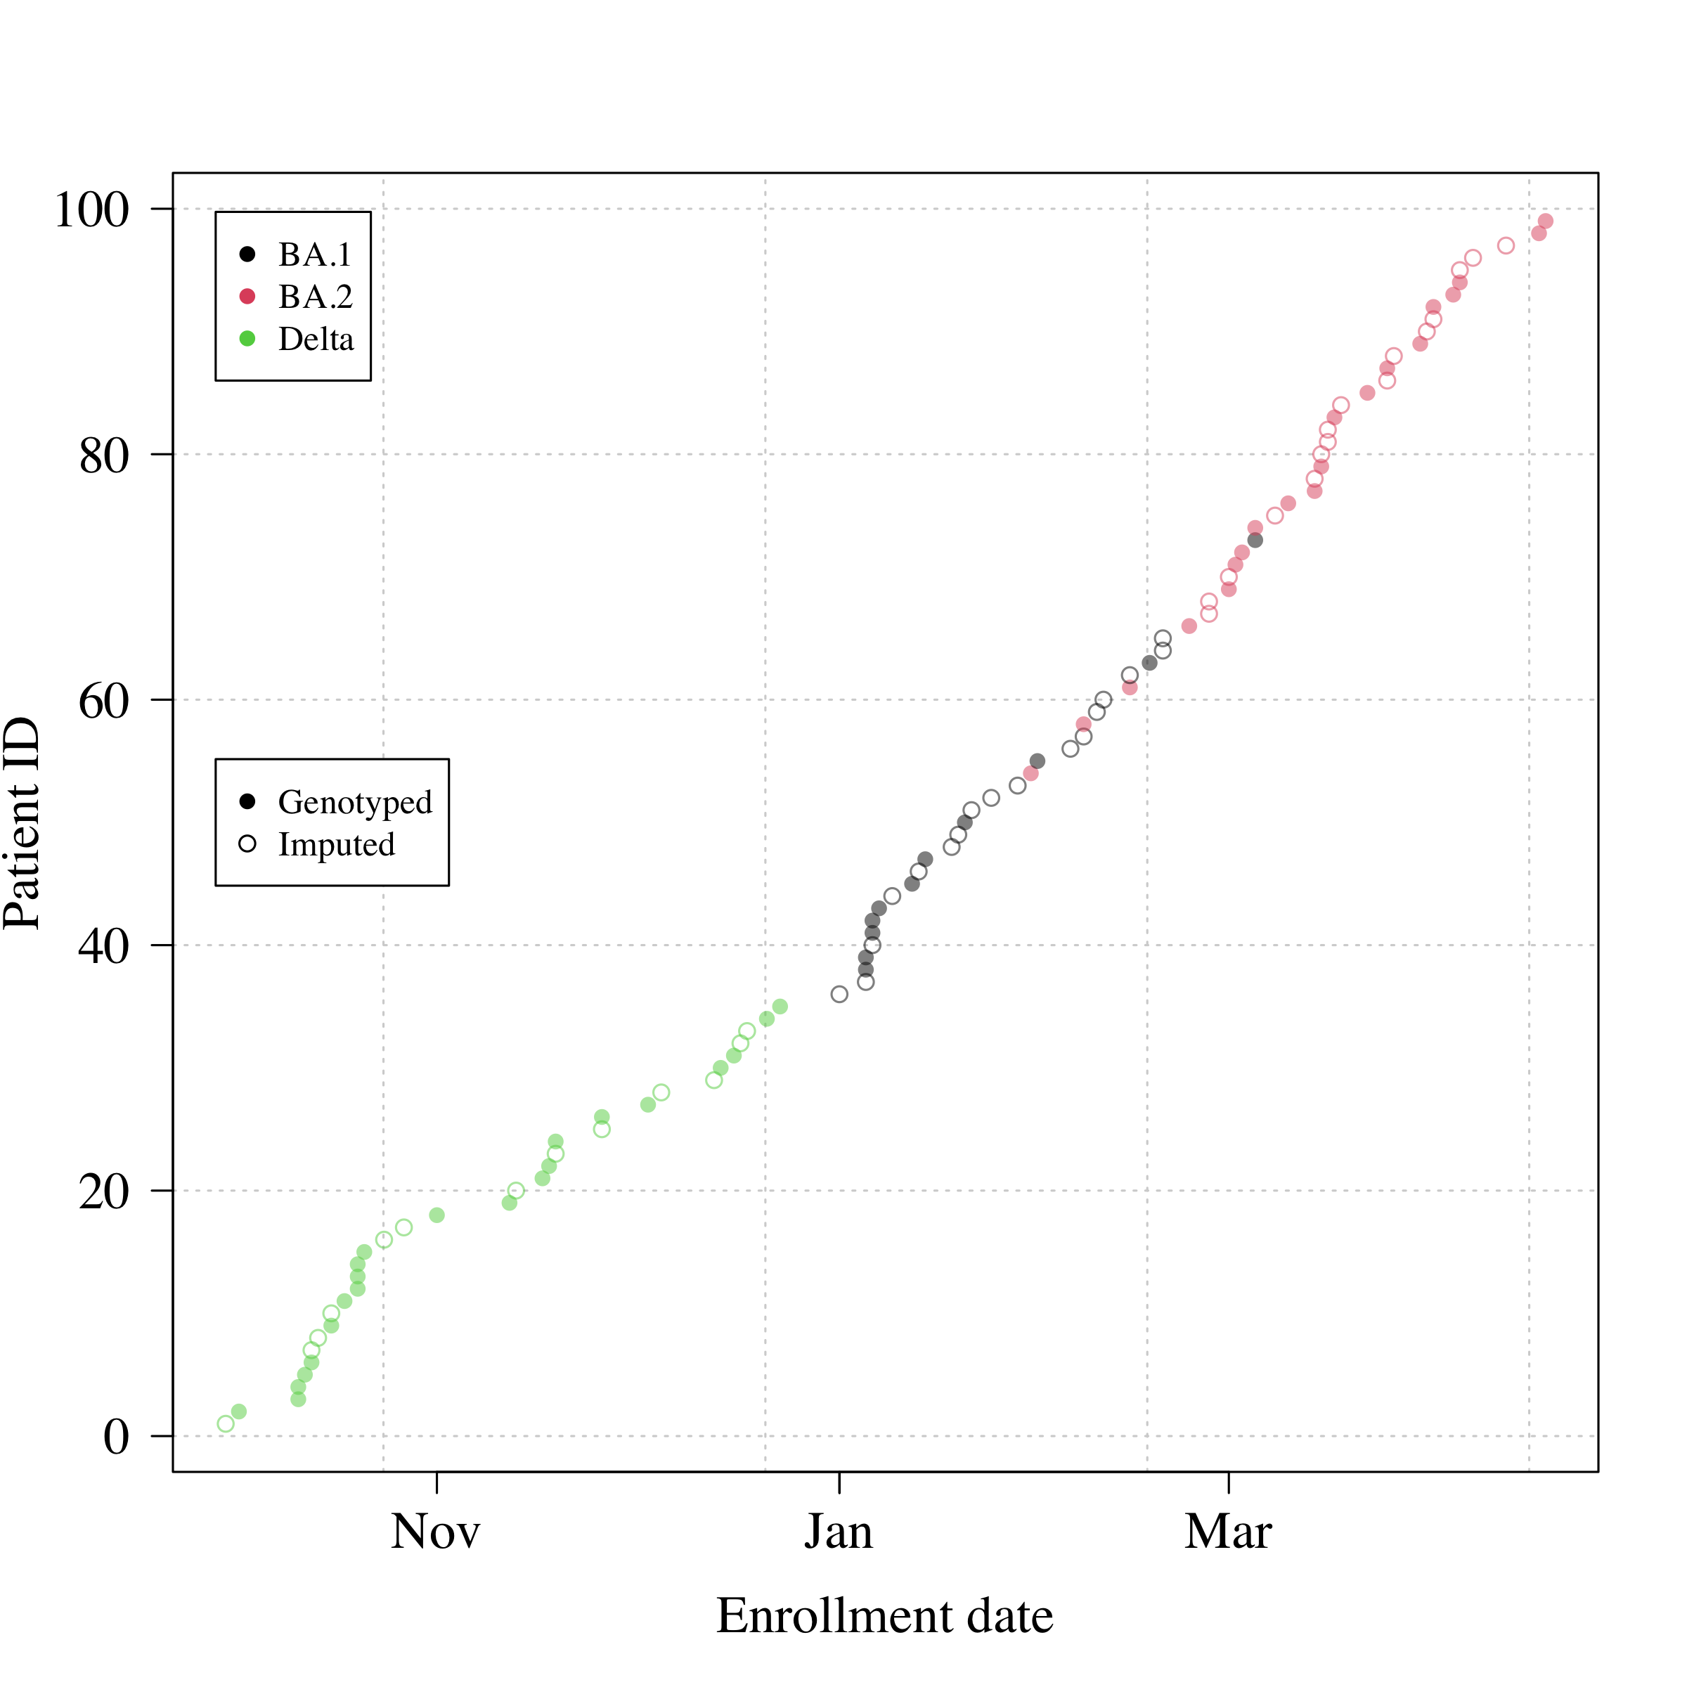

## [1] TRUE

## The analysis dataset contains 96 patients. The geometric mean baseline (defined as samples taken within 6 hours of randomisation) viral load was 360579 copies per mL (IQR: 78404 to 2759408; range from 63 to 80395244)

Summary table

## [1] "Ivermectin" "Casirivimab\nimdevimab" "No study drug"

Summary of patient characteristics included in the current interim analysis (n= 96). Age: median (range); baseline viral load (log10 copies per mL: mean (range)); vaccinated: % with any number of doses; number of vaccine doses: median (range); antibody data are from rapid tests done at screening (+ is presence of IgM or IgG band).

| Arm | n | Age | Baseline viral load (log10) | Vaccinated (%) | Number of vaccine doses | Antibody+ (%) | Male (%) | th001 | th057 | th058 |
| --- | --- | --- | --- | --- | --- | --- | --- | --- | --- | --- |
| Casirivimab |  |  |  |  |  |  |  |  |  |  |
| imdevimab | 10 | 26.5 (18-31) | 5.5 (3.7-7.8) | 80 | 2 (0-3) | 50 | 20 | 10 | 0 | 0 |
| Ivermectin | 45 | 29 (19-45) | 5.7 (1.9-7.6) | 98 | 2 (0-4) | 78 | 47 | 41 | 2 | 2 |
| No study drug | 41 | 27 (20-43) | 5.5 (3-7.7) | 100 | 2 (2-4) | 90 | 44 | 36 | 3 | 2 |

## Summary data plot

## Plotting data for 96 individuals

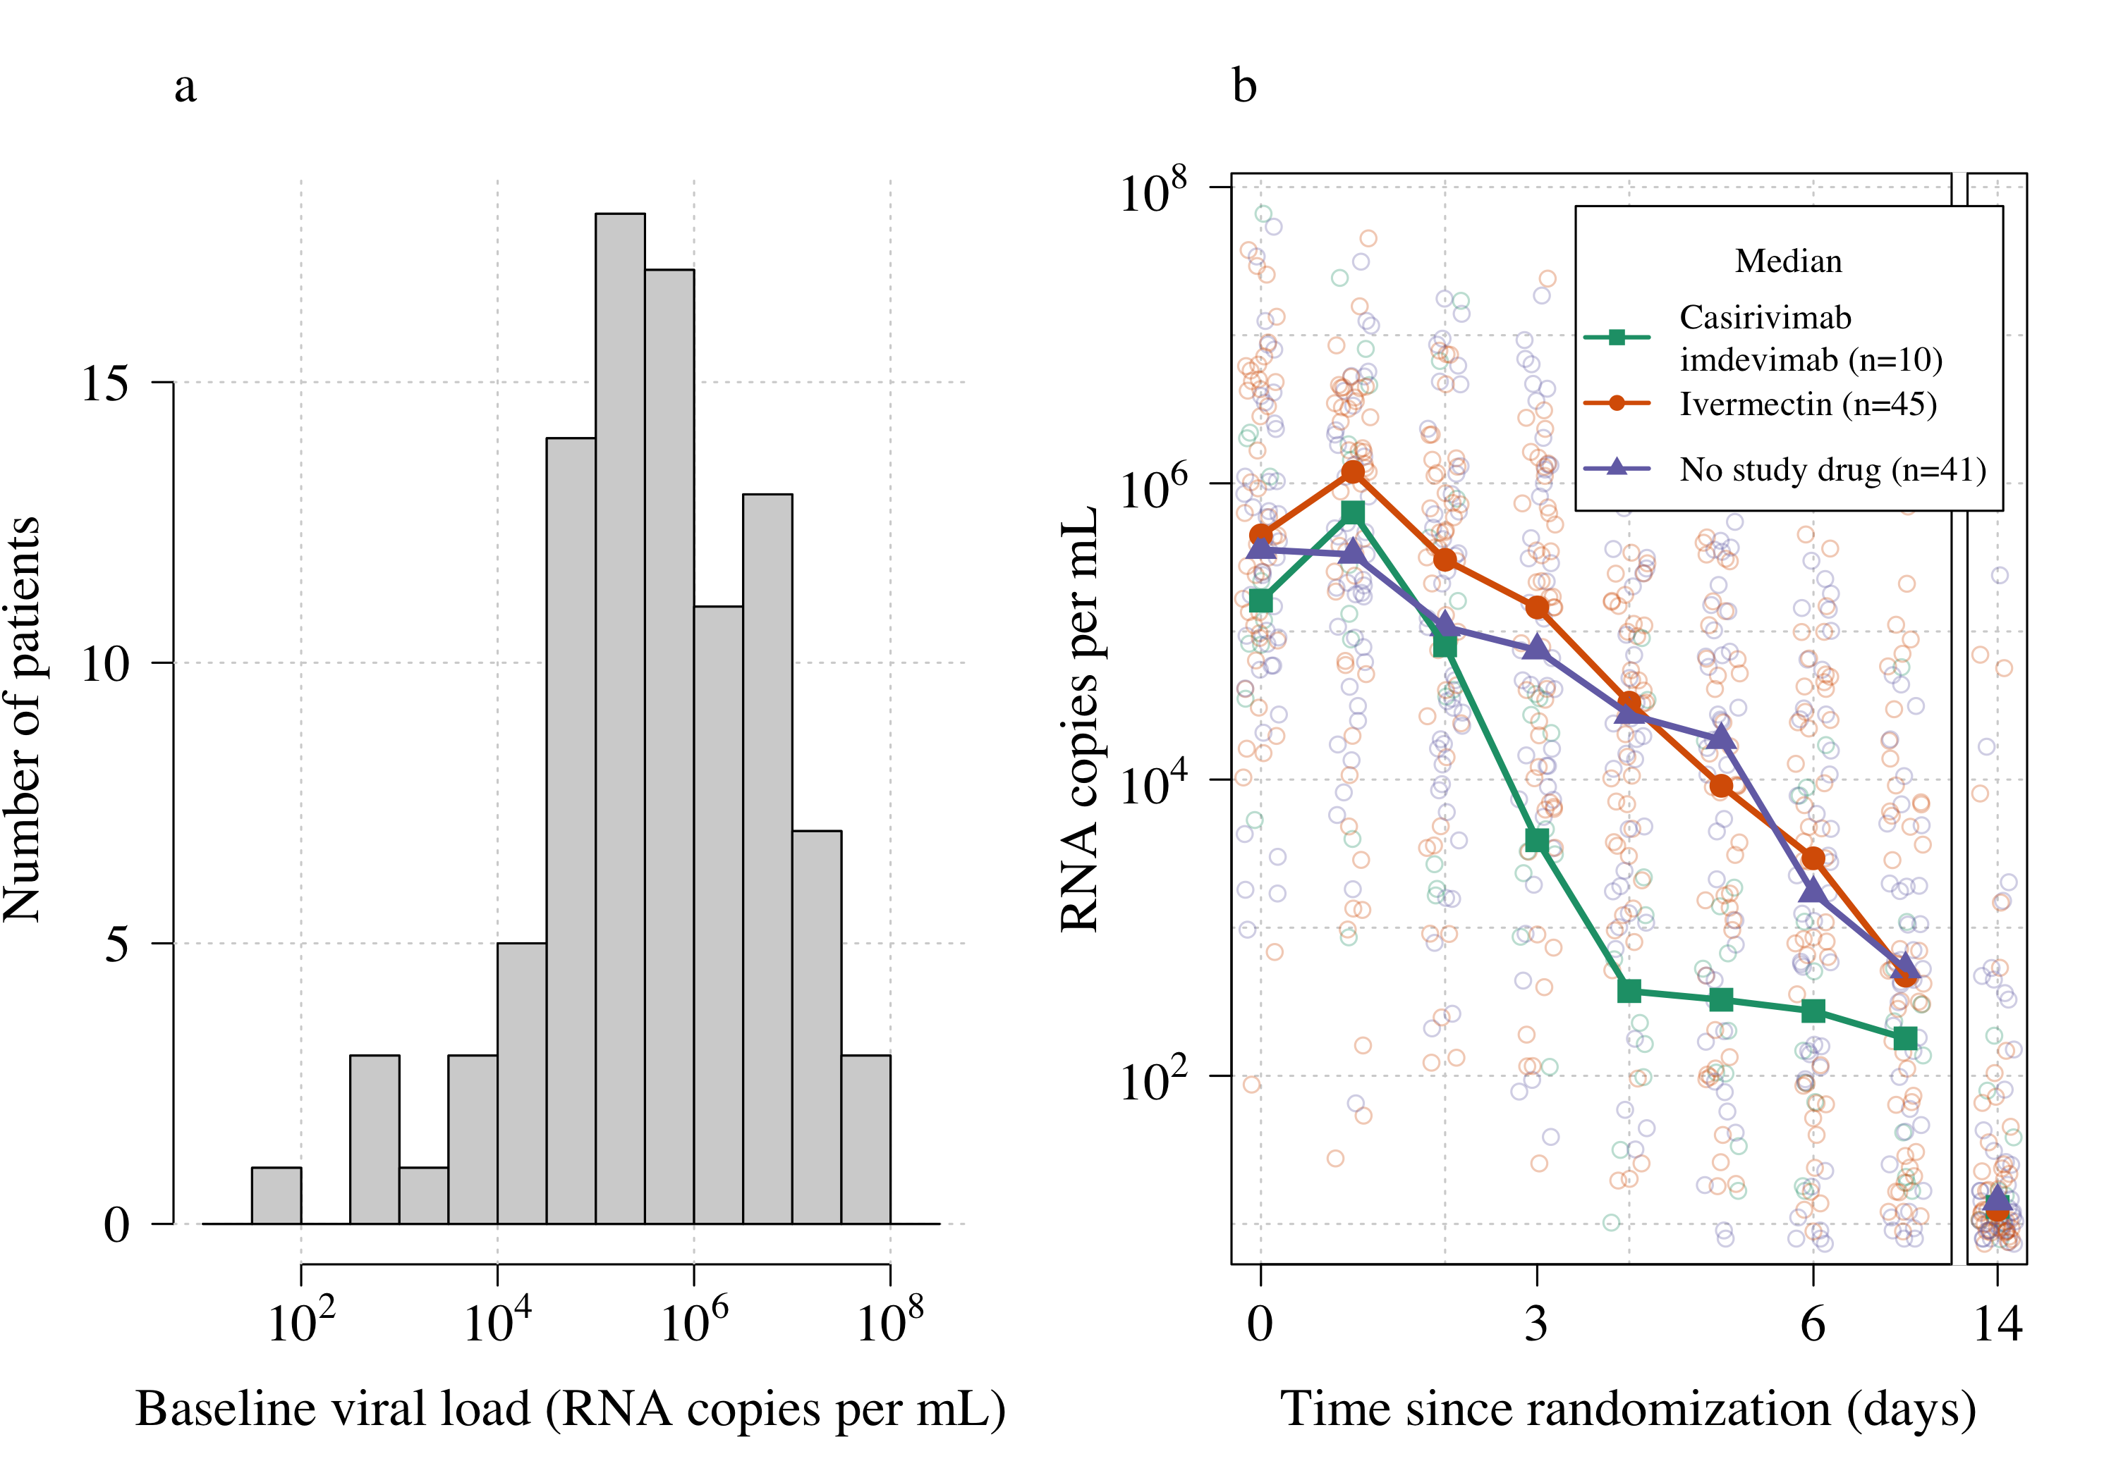

## Model fitting

### Specify priors

### Prepare model

Make stan data set.

Covariates that we use in model 2:

* Vaccination (number of doses)
* Age (standardised to have mean=0 and sd=1)
* Time since symptom onset (days, between 0 and 4)
* Variant (WHO variants of concern) - when available (this is replaced by epoch until we have variant data)
* Serology rapid test (+/-)
* Serum antibody: not yet decided which antibody will be measured - expected May/June 2022

## Total number of datapoints up until day 8 is 1700

## Number of patients per arm in analysis:

##   
## No study drug Casirivimab\nimdevimab Ivermectin   
## 41 10 45

## There are a total of 96 patients in the database with a total of 1700 PCRs analysable  
## 7.12% of samples are below LOD  
## check stan data formatting:

### Setup model runs

We fit a sequence of Bayesian hierarchical models. To make sure there are no bugs in the code (all stan code is written specifically for this trial analysis), I fit the following sequence of five models of increasing complexity:

* Model 0: vanilla student-t regression with left censoring at 0 and with individual random effects for slope and intercept;
* Model 1: add the RNaseP measurements;
* Model 2: Add covariate adjustment;
* Model 3: Non-linear model (up and then down) with RNaseP adjustment.

## [1] "../Stan_models/Linear_model_basic.stan"   
## [2] "../Stan_models/Linear_model_RNaseP.stan"   
## [3] "../Stan_models/Nonlinear_model_RNaseP.stan"

## We are running all models with 4 chains and 10000 samples for each chain, discarding half for burn-in and thining every 30, thus giving a total of 1200 posterior samples per model.

Load model fits

### Model fits: summaries

### Model comparisons using loo

## Results

### Estimated treatment effects under the 4 models

Posterior distributions over the treatment effects for the interventions. Red: no effect; blue: median inferred effect.

##   
## *******************  
## Mean estimated treatment effects (multiplicative):

## Casirivimab\nimdevimab Ivermectin  
## [1,] 1.606569 0.9057598  
## [2,] 1.552534 0.9119189  
## [3,] 1.479141 0.9129407  
## [4,] 1.682005 0.9254563  
## [5,] 1.562946 0.9110849  
## [6,] 1.546228 0.9221675  
## [7,] 1.465852 0.9220199  
## [8,] 1.668224 0.9312359  
## [9,] 1.521437 0.9145647

##   
## *******************  
## Probability of super-superiority:

## Casirivimab\nimdevimab Ivermectin  
## [1,] 96.2 3.2  
## [2,] 96.8 2.4  
## [3,] 93.7 1.4  
## [4,] 97.7 5.1  
## [5,] 96.2 1.4  
## [6,] 95.2 3.9  
## [7,] 93.8 2.2  
## [8,] 95.8 4.4  
## [9,] 96.2 2.3

Overall effects

## mean sd 2.5% 97.5% n_eff  
## trt_effect[1] 0.439888637 0.17934459 0.09960327 0.7962699 1254.1722  
## trt_effect[2] -0.092204211 0.11091826 -0.31184301 0.1165217 1293.0637  
## alpha_0 5.376053376 0.20737297 4.97711203 5.7713613 1202.6199  
## beta_0 -0.393258717 0.05308808 -0.50397721 -0.2993492 923.8939  
## sigma_logvl 0.918595705 0.03082043 0.85824143 0.9824783 1239.7395  
## sigmasq_u[1] 0.944248379 0.08594156 0.79412882 1.1260287 1111.5958  
## sigmasq_u[2] 0.491408783 0.05762955 0.38986451 0.6233133 1148.9370  
## t_dof 6.406923088 1.15074675 4.61178316 9.1687686 1155.5419  
## gamma_rnasep 0.212751834 0.02973523 0.15754763 0.2717516 1189.6898  
## slope_coefs[1] 0.036787854 0.14932143 -0.25367176 0.3354384 1168.3910  
## slope_coefs[2] -0.049529172 0.16025225 -0.35438203 0.2742960 1144.4142  
## slope_coefs[3] 0.402033598 0.24506979 -0.07397654 0.8623881 1182.4303  
## slope_coefs[4] 0.004732043 0.30463116 -0.61702613 0.5948953 1157.6187  
## intercept_coefs[1] 0.929006765 0.25498617 0.42861423 1.4514274 1188.0568  
## intercept_coefs[2] 0.301949535 0.26267776 -0.19173216 0.8233794 1189.7200  
## intercept_coefs[3] -0.430171778 0.42821058 -1.26408866 0.4022732 1191.5614  
## intercept_coefs[4] -0.676360801 0.46784331 -1.56210113 0.2542441 1259.7549  
## Rhat  
## trt_effect[1] 0.9974927  
## trt_effect[2] 0.9979626  
## alpha_0 1.0001441  
## beta_0 0.9991269  
## sigma_logvl 0.9978665  
## sigmasq_u[1] 0.9994497  
## sigmasq_u[2] 0.9984864  
## t_dof 0.9983689  
## gamma_rnasep 0.9989161  
## slope_coefs[1] 0.9978297  
## slope_coefs[2] 0.9985918  
## slope_coefs[3] 1.0030934  
## slope_coefs[4] 0.9994791  
## intercept_coefs[1] 0.9981466  
## intercept_coefs[2] 1.0025176  
## intercept_coefs[3] 0.9997953  
## intercept_coefs[4] 0.9979061

## Under model 2 the treatment effect for ivermectin is 0.91 (95% 0.73 to 1.1)

## Under model 2 the treatment effect for Regeneron is 1.6 (95% 1.1 to 2.2)

## The main 3 models with weakly informative priors:

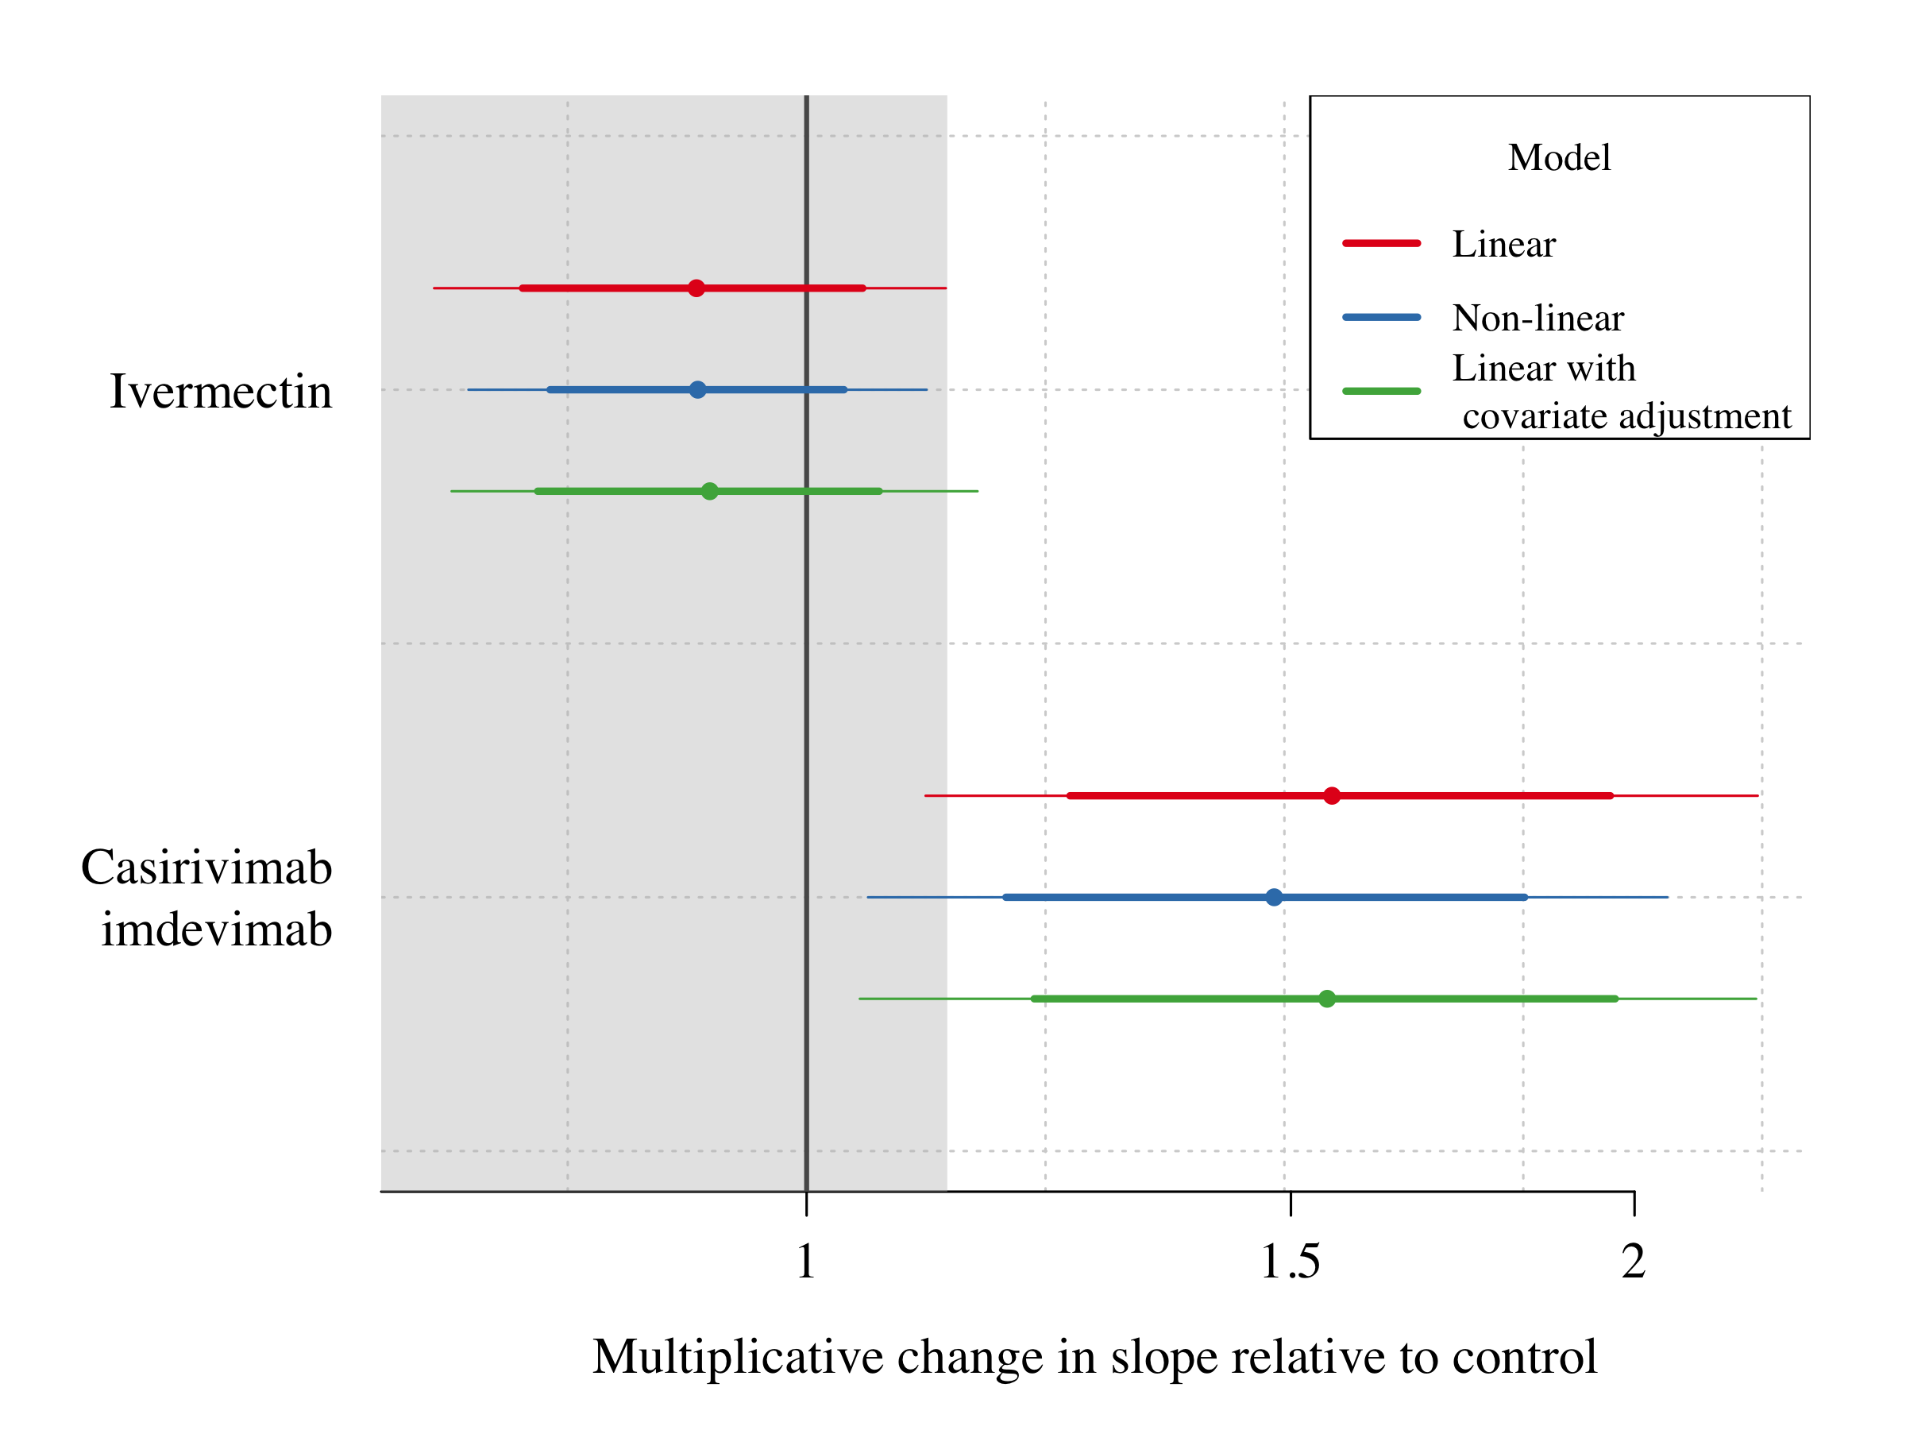

Covariate effects on the intercept (baseline viral load) and slope (viral clearance):

## The following `from` values were not present in `x`: Age_scaled, Antibody_test, Symptom_onset, N_dose  
## The following `from` values were not present in `x`: Age_scaled, Antibody_test, Symptom_onset, N_dose

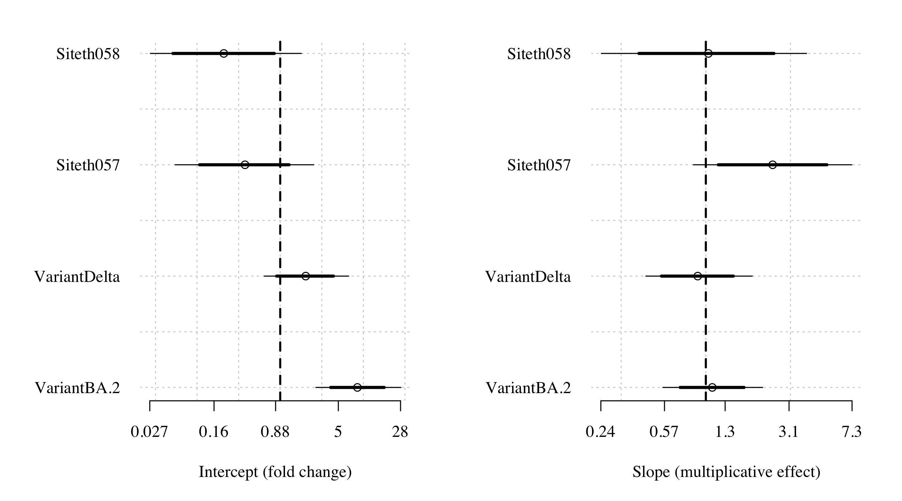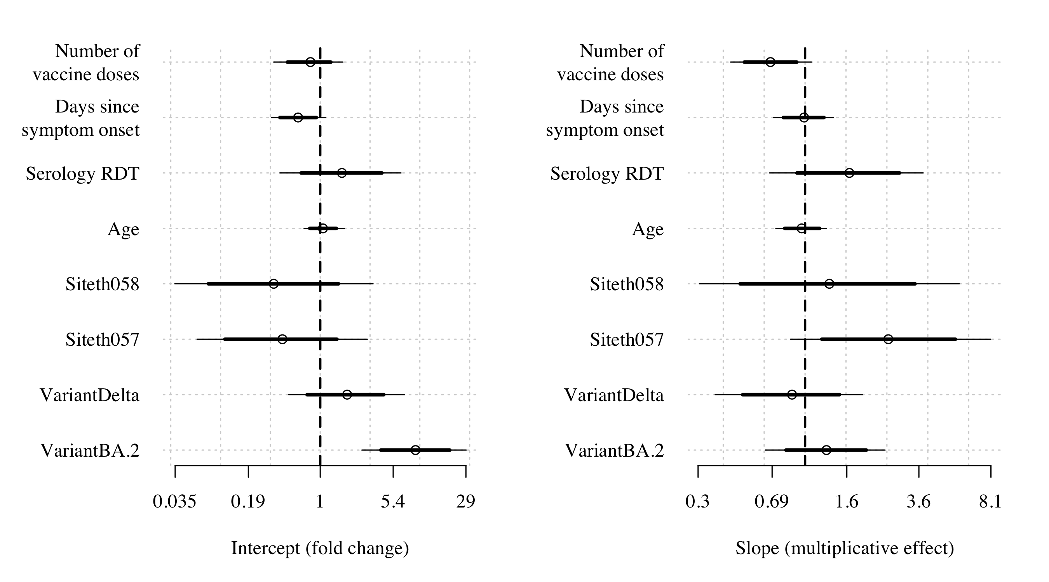

### Slopes over time

Plot the absolute slope estimate for each individual over time

## The following `from` values were not present in `x`: PLT-TH1-018, PLT-TH1-020, PLT-TH1-105  
## The following `from` values were not present in `x`: PLT-TH1-018, PLT-TH1-020, PLT-TH1-105  
## The following `from` values were not present in `x`: PLT-TH1-018, PLT-TH1-020, PLT-TH1-105

## Slopes plot for model setting 2

## mod prior cov_matrices Niter Nwarmup  
## 2 ../Stan_models/Linear_model_RNaseP.stan 1 1 10000 1000  
## Nthin Nchain  
## 2 30 4

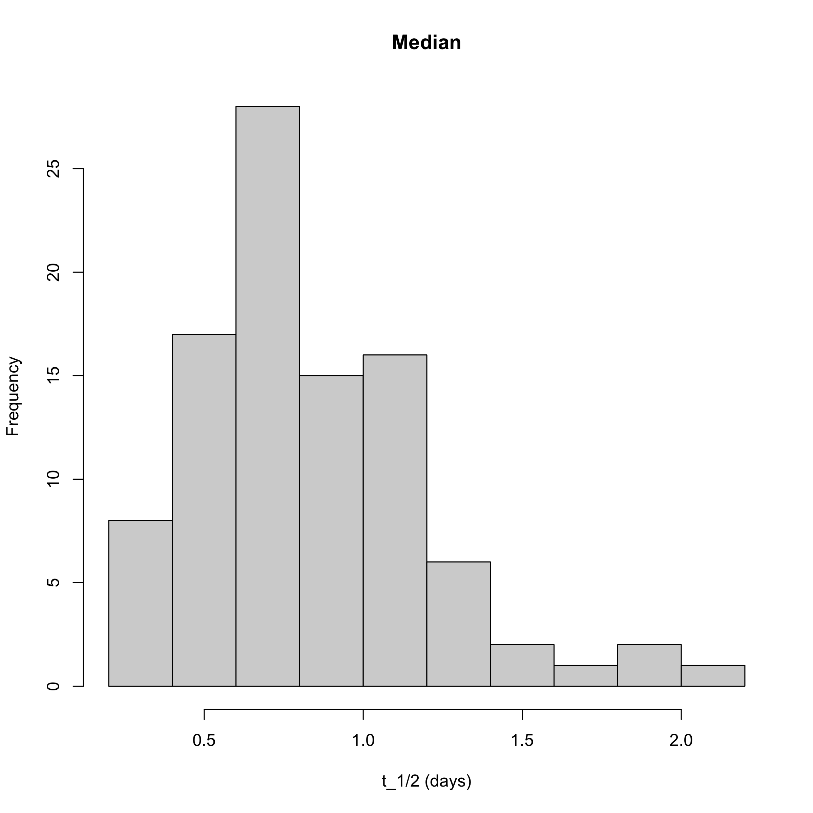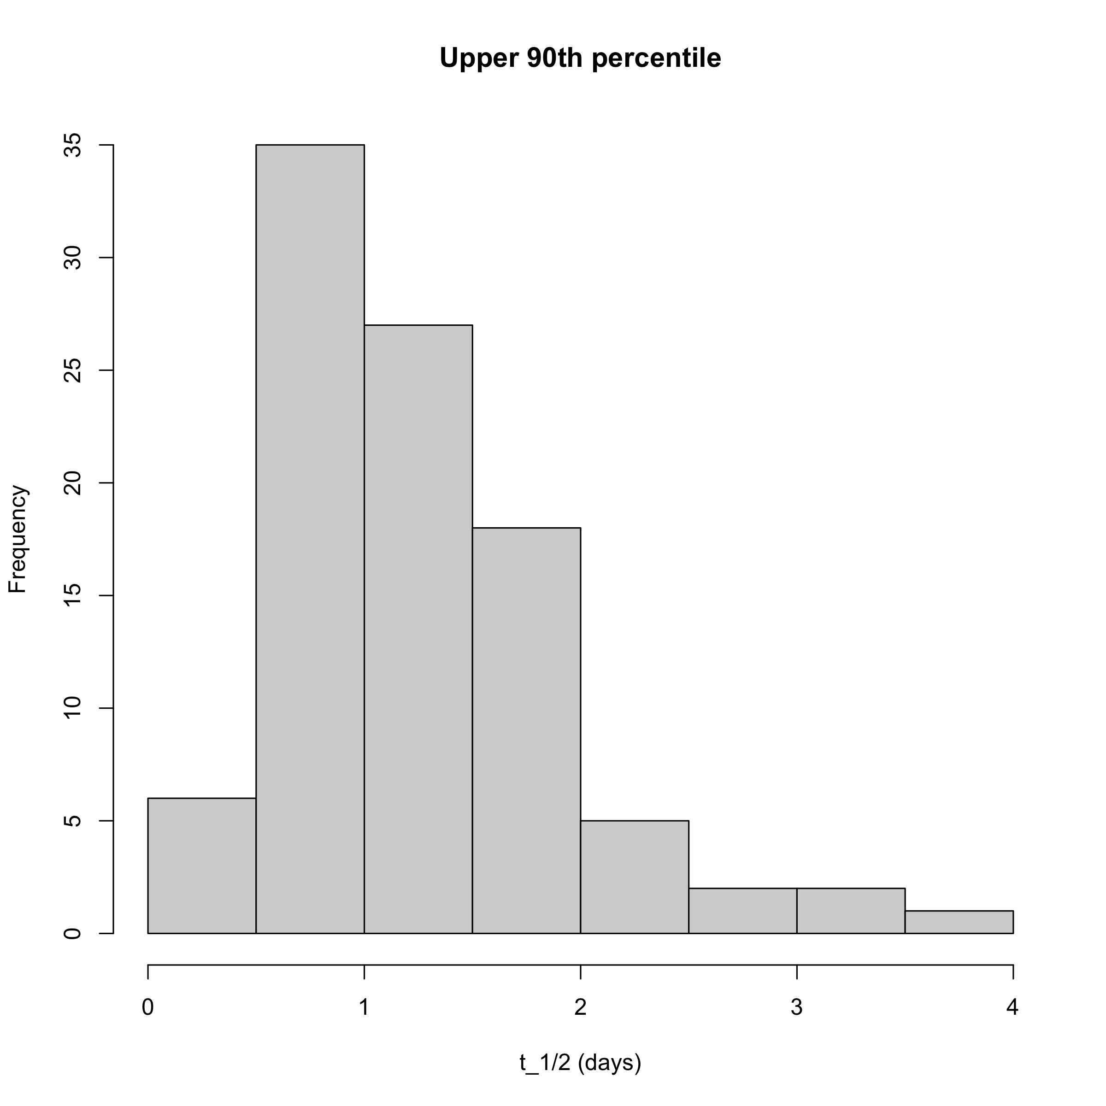

## In the no study drug arm the mean clearance half life was 21.6 (range 8.9 to 48.5)

## In the ivermectin arm the mean clearance half life was 19.3 (range 7.1 to 41.8)

## In the ivermectin arm the mean clearance half life was 12 (range 5.8 to 18.7)

## The model estimated population mean clearance half-life is 18.7 (95% CI 14.3-24.1)

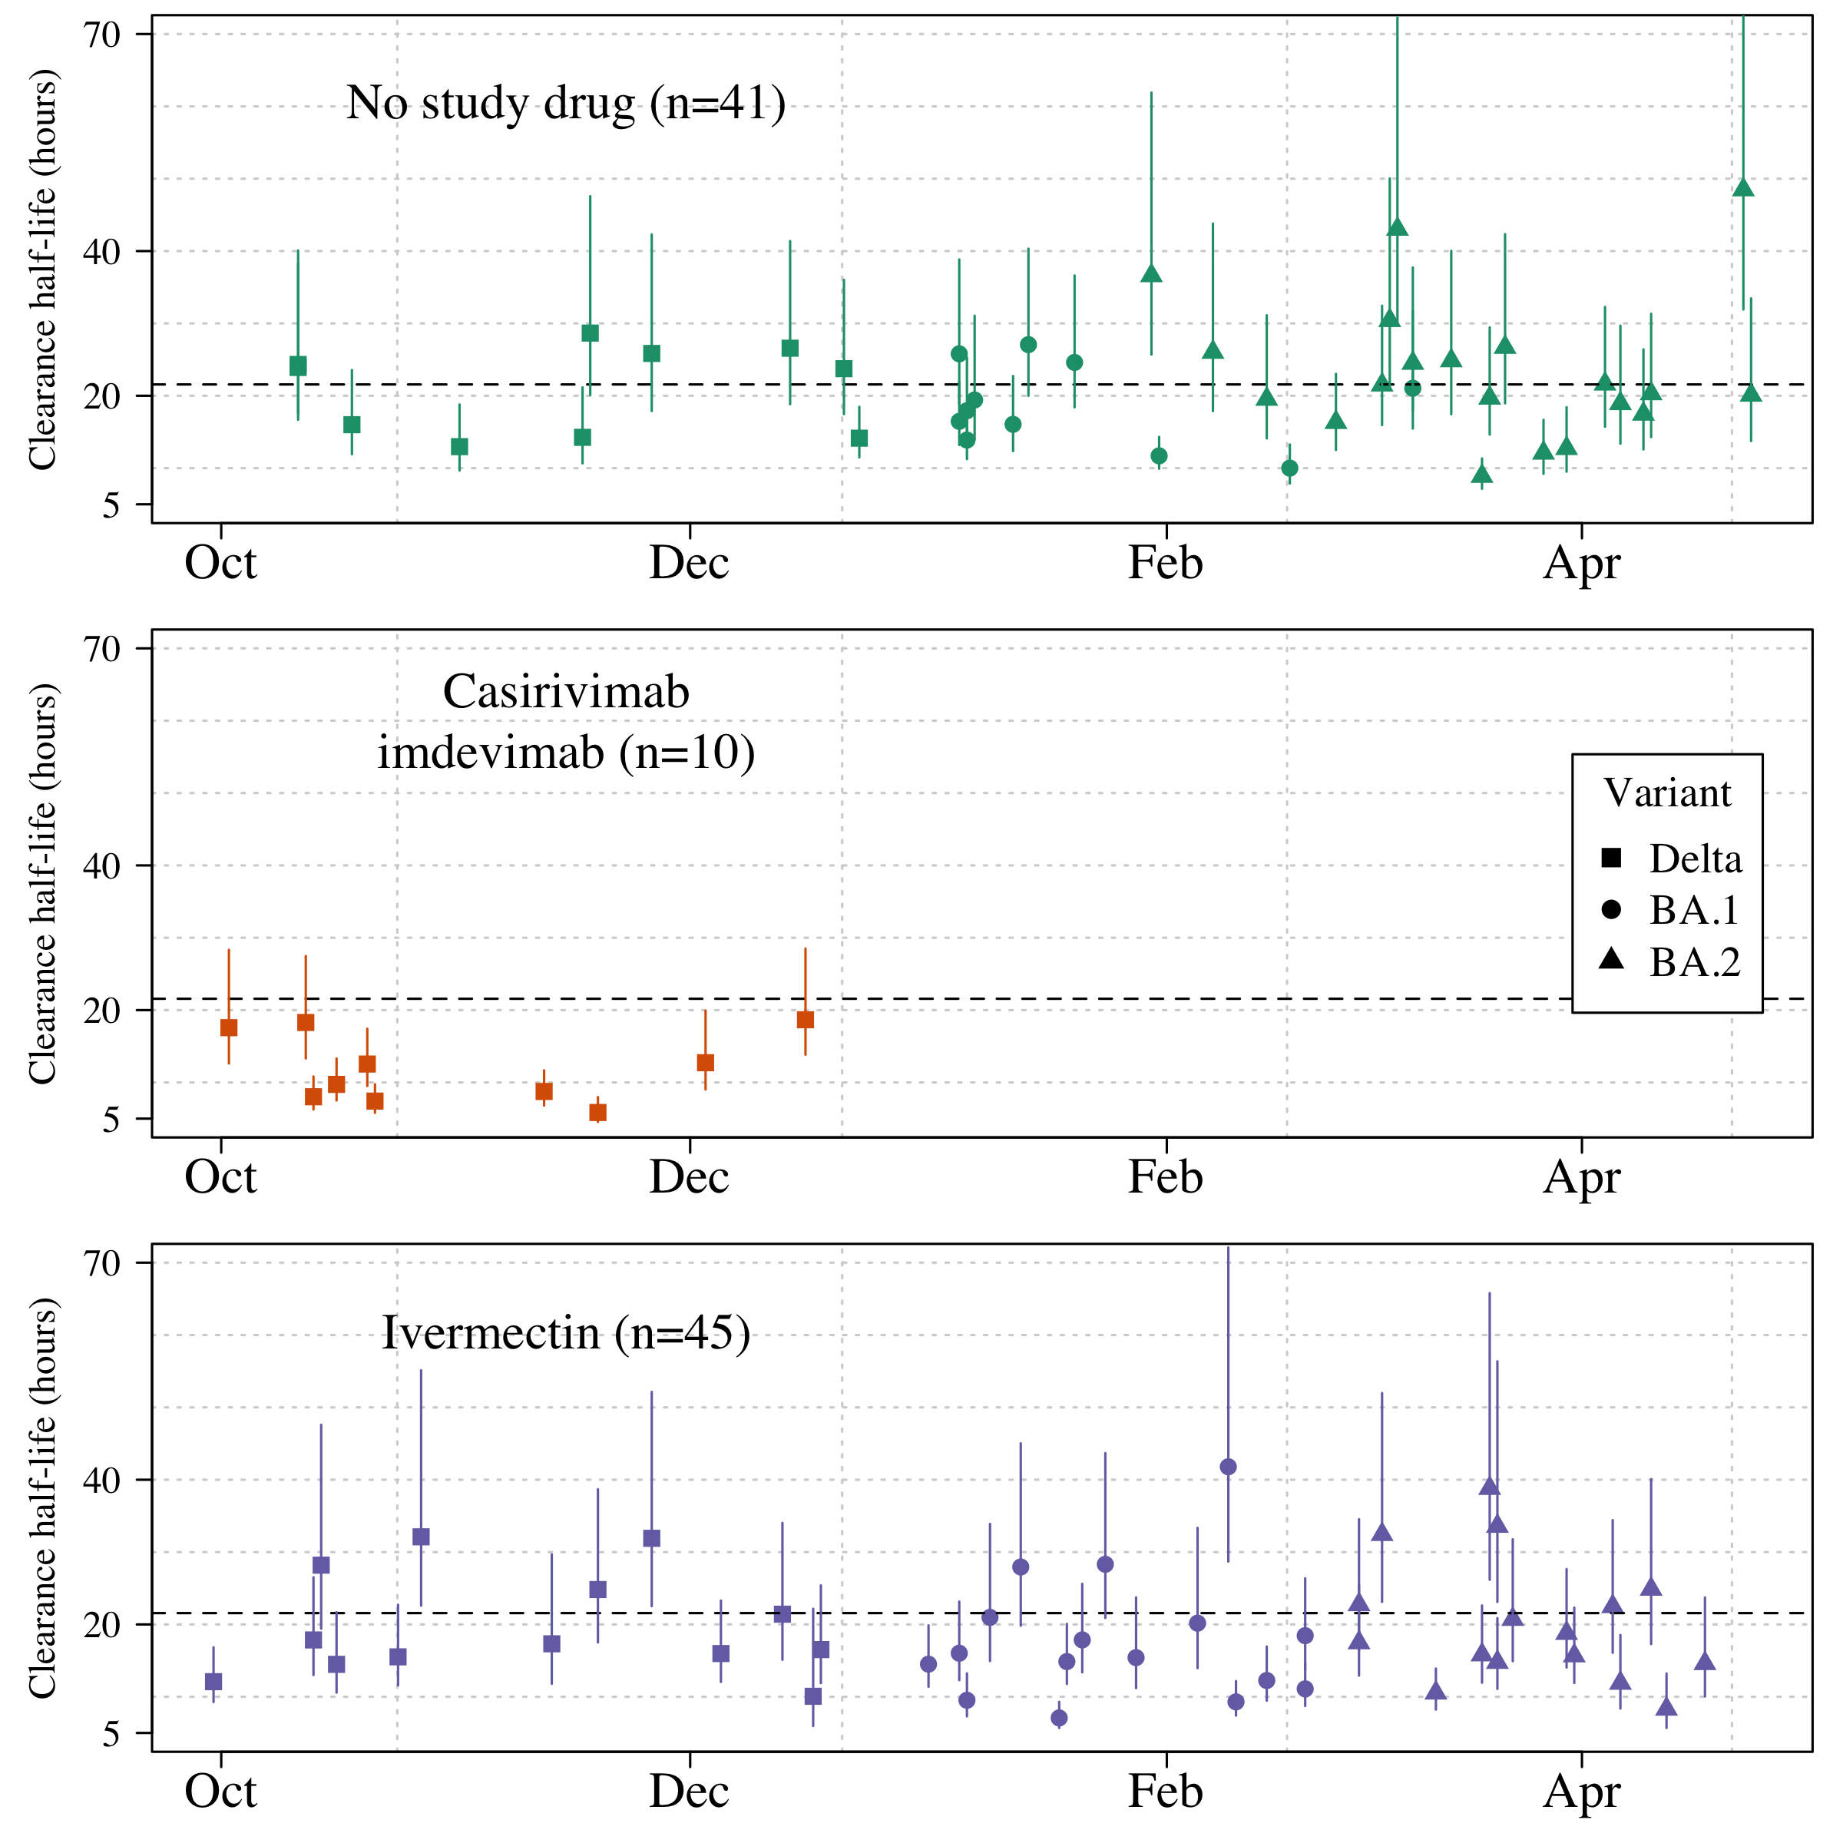

changes in half life

## In the Ivermectin arm the mean change in half life is 1.8 (95% CI -2.4 to 6.3)

## In the Regeneron arm the mean change in half life is -6.5 (95% CI -11 to -1.8)

Plot the individual slope estimates by group

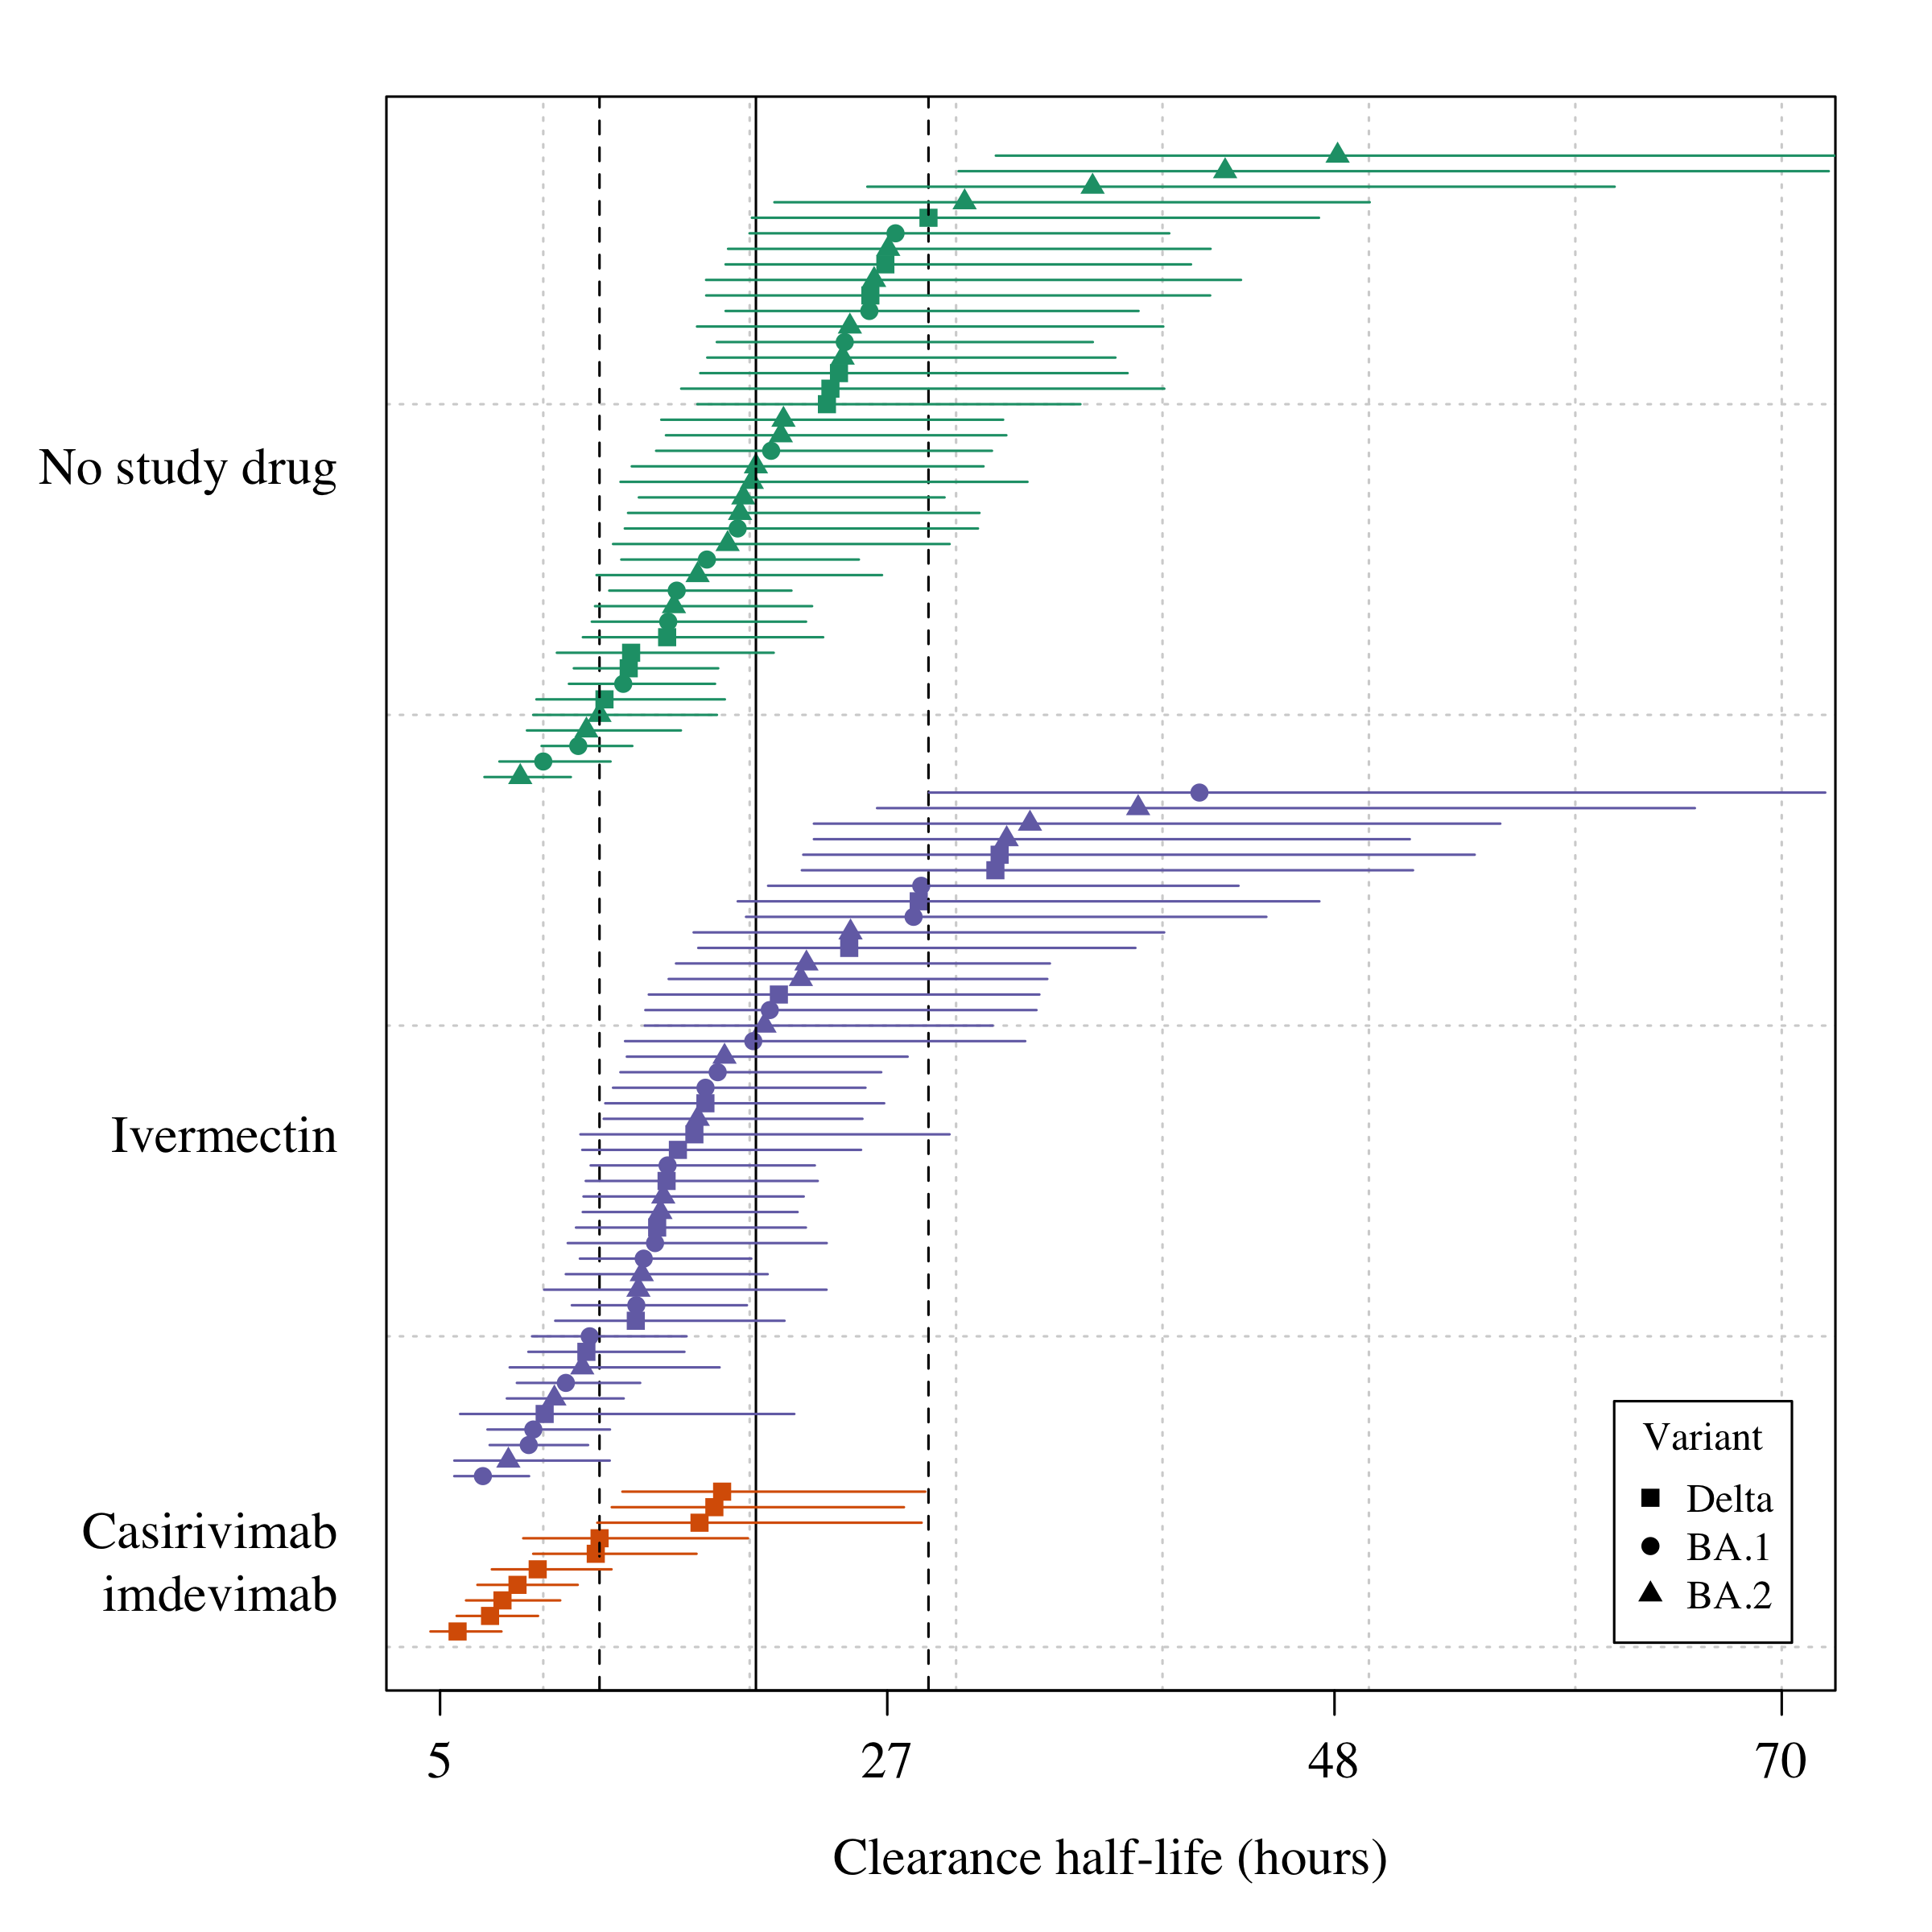

Some exploratory covariate analyses

##   
## Call:  
## lm(formula = t_12 ~ trt, data = trt_summary_dat)  
##   
## Residuals:  
## Min 1Q Median 3Q Max   
## -12.682 -4.870 -1.628 4.243 26.917   
##   
## Coefficients:  
## Estimate Std. Error t value Pr(>|t|)   
## (Intercept) 21.567 1.241 17.378 < 2e-16 ***  
## trtCasirivimab\nimdevimab -9.610 2.803 -3.429 0.000906 ***  
## trtIvermectin -2.292 1.716 -1.336 0.184921   
## ---  
## Signif. codes: 0 '***' 0.001 '**' 0.01 '*' 0.05 '.' 0.1 ' ' 1  
##   
## Residual standard error: 7.947 on 93 degrees of freedom  
## Multiple R-squared: 0.1128, Adjusted R-squared: 0.09367   
## F-statistic: 5.909 on 2 and 93 DF, p-value: 0.003838

### Individual plots

Individual plots colored by model

## The following `from` values were not present in `x`: PLT-TH1-018, PLT-TH1-020, PLT-TH1-105

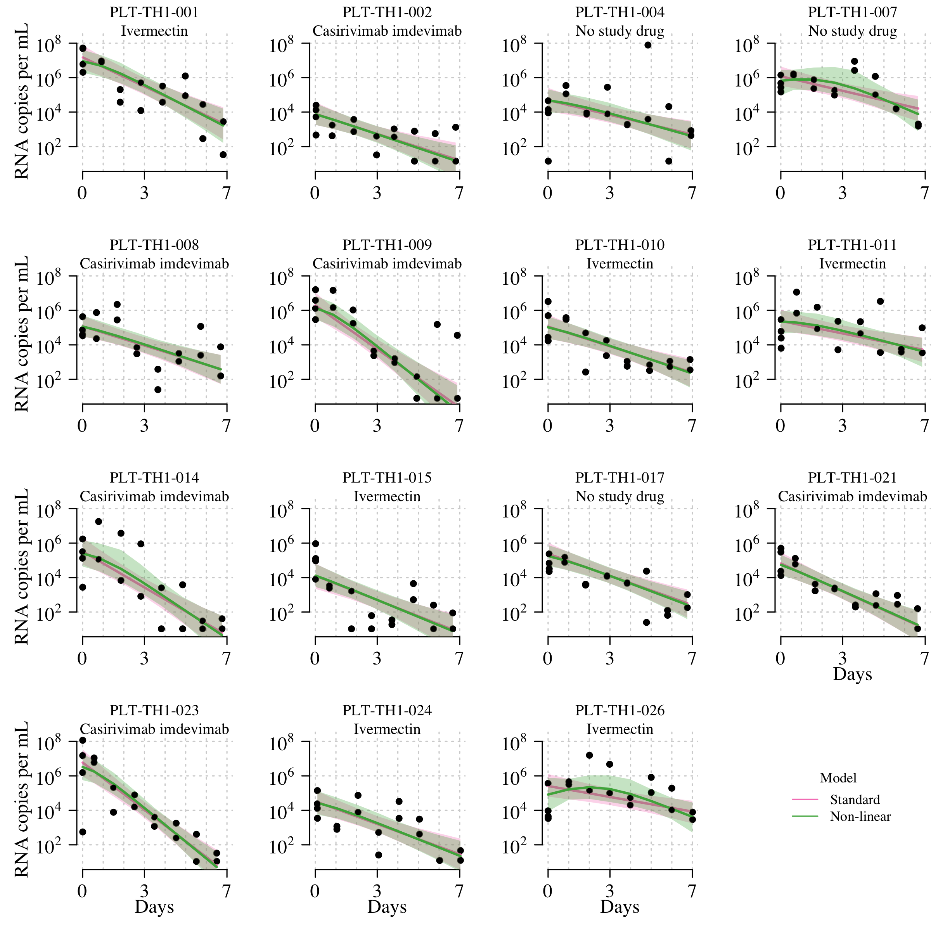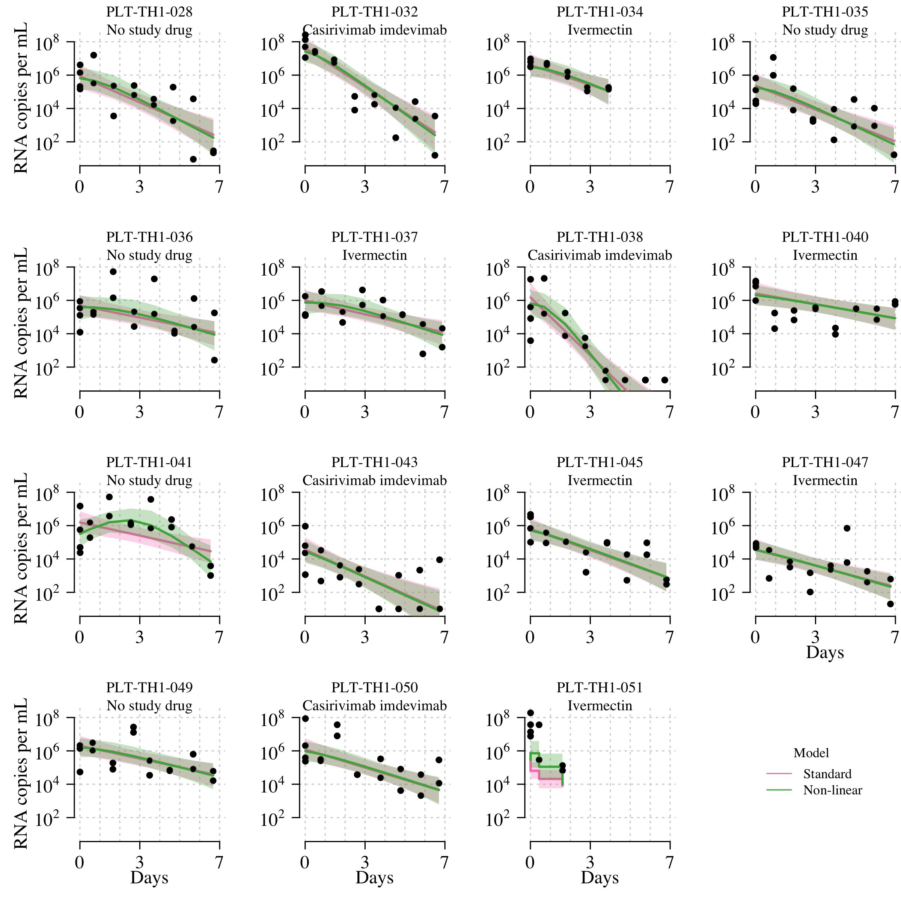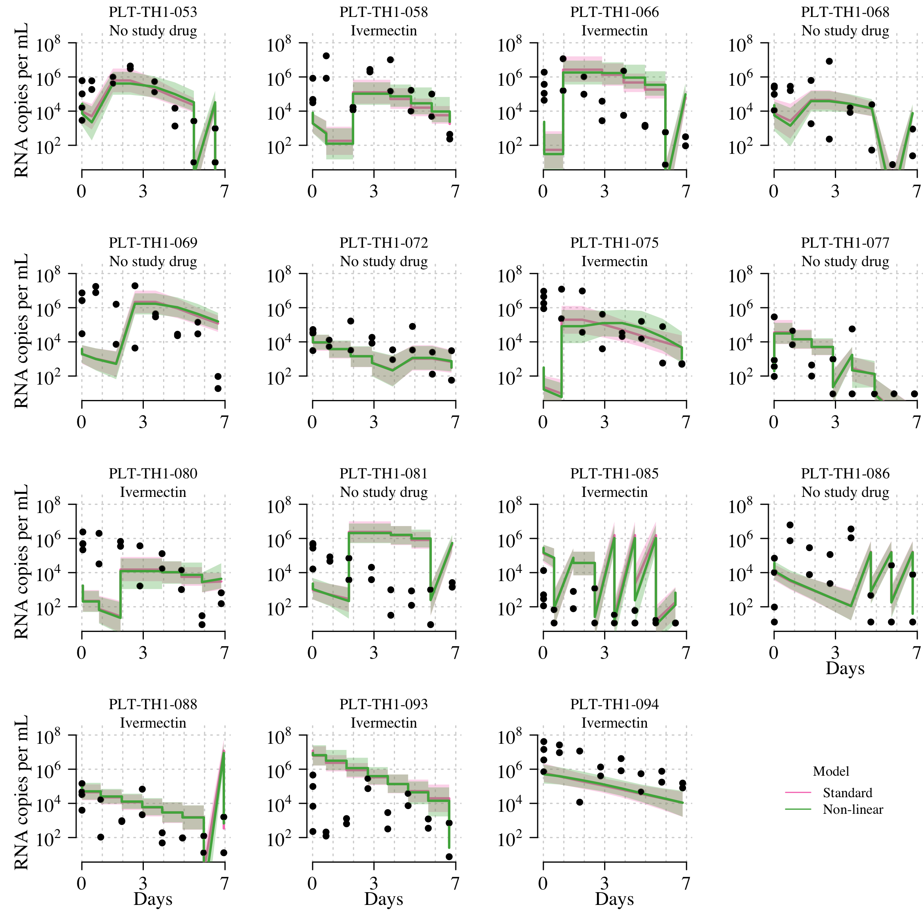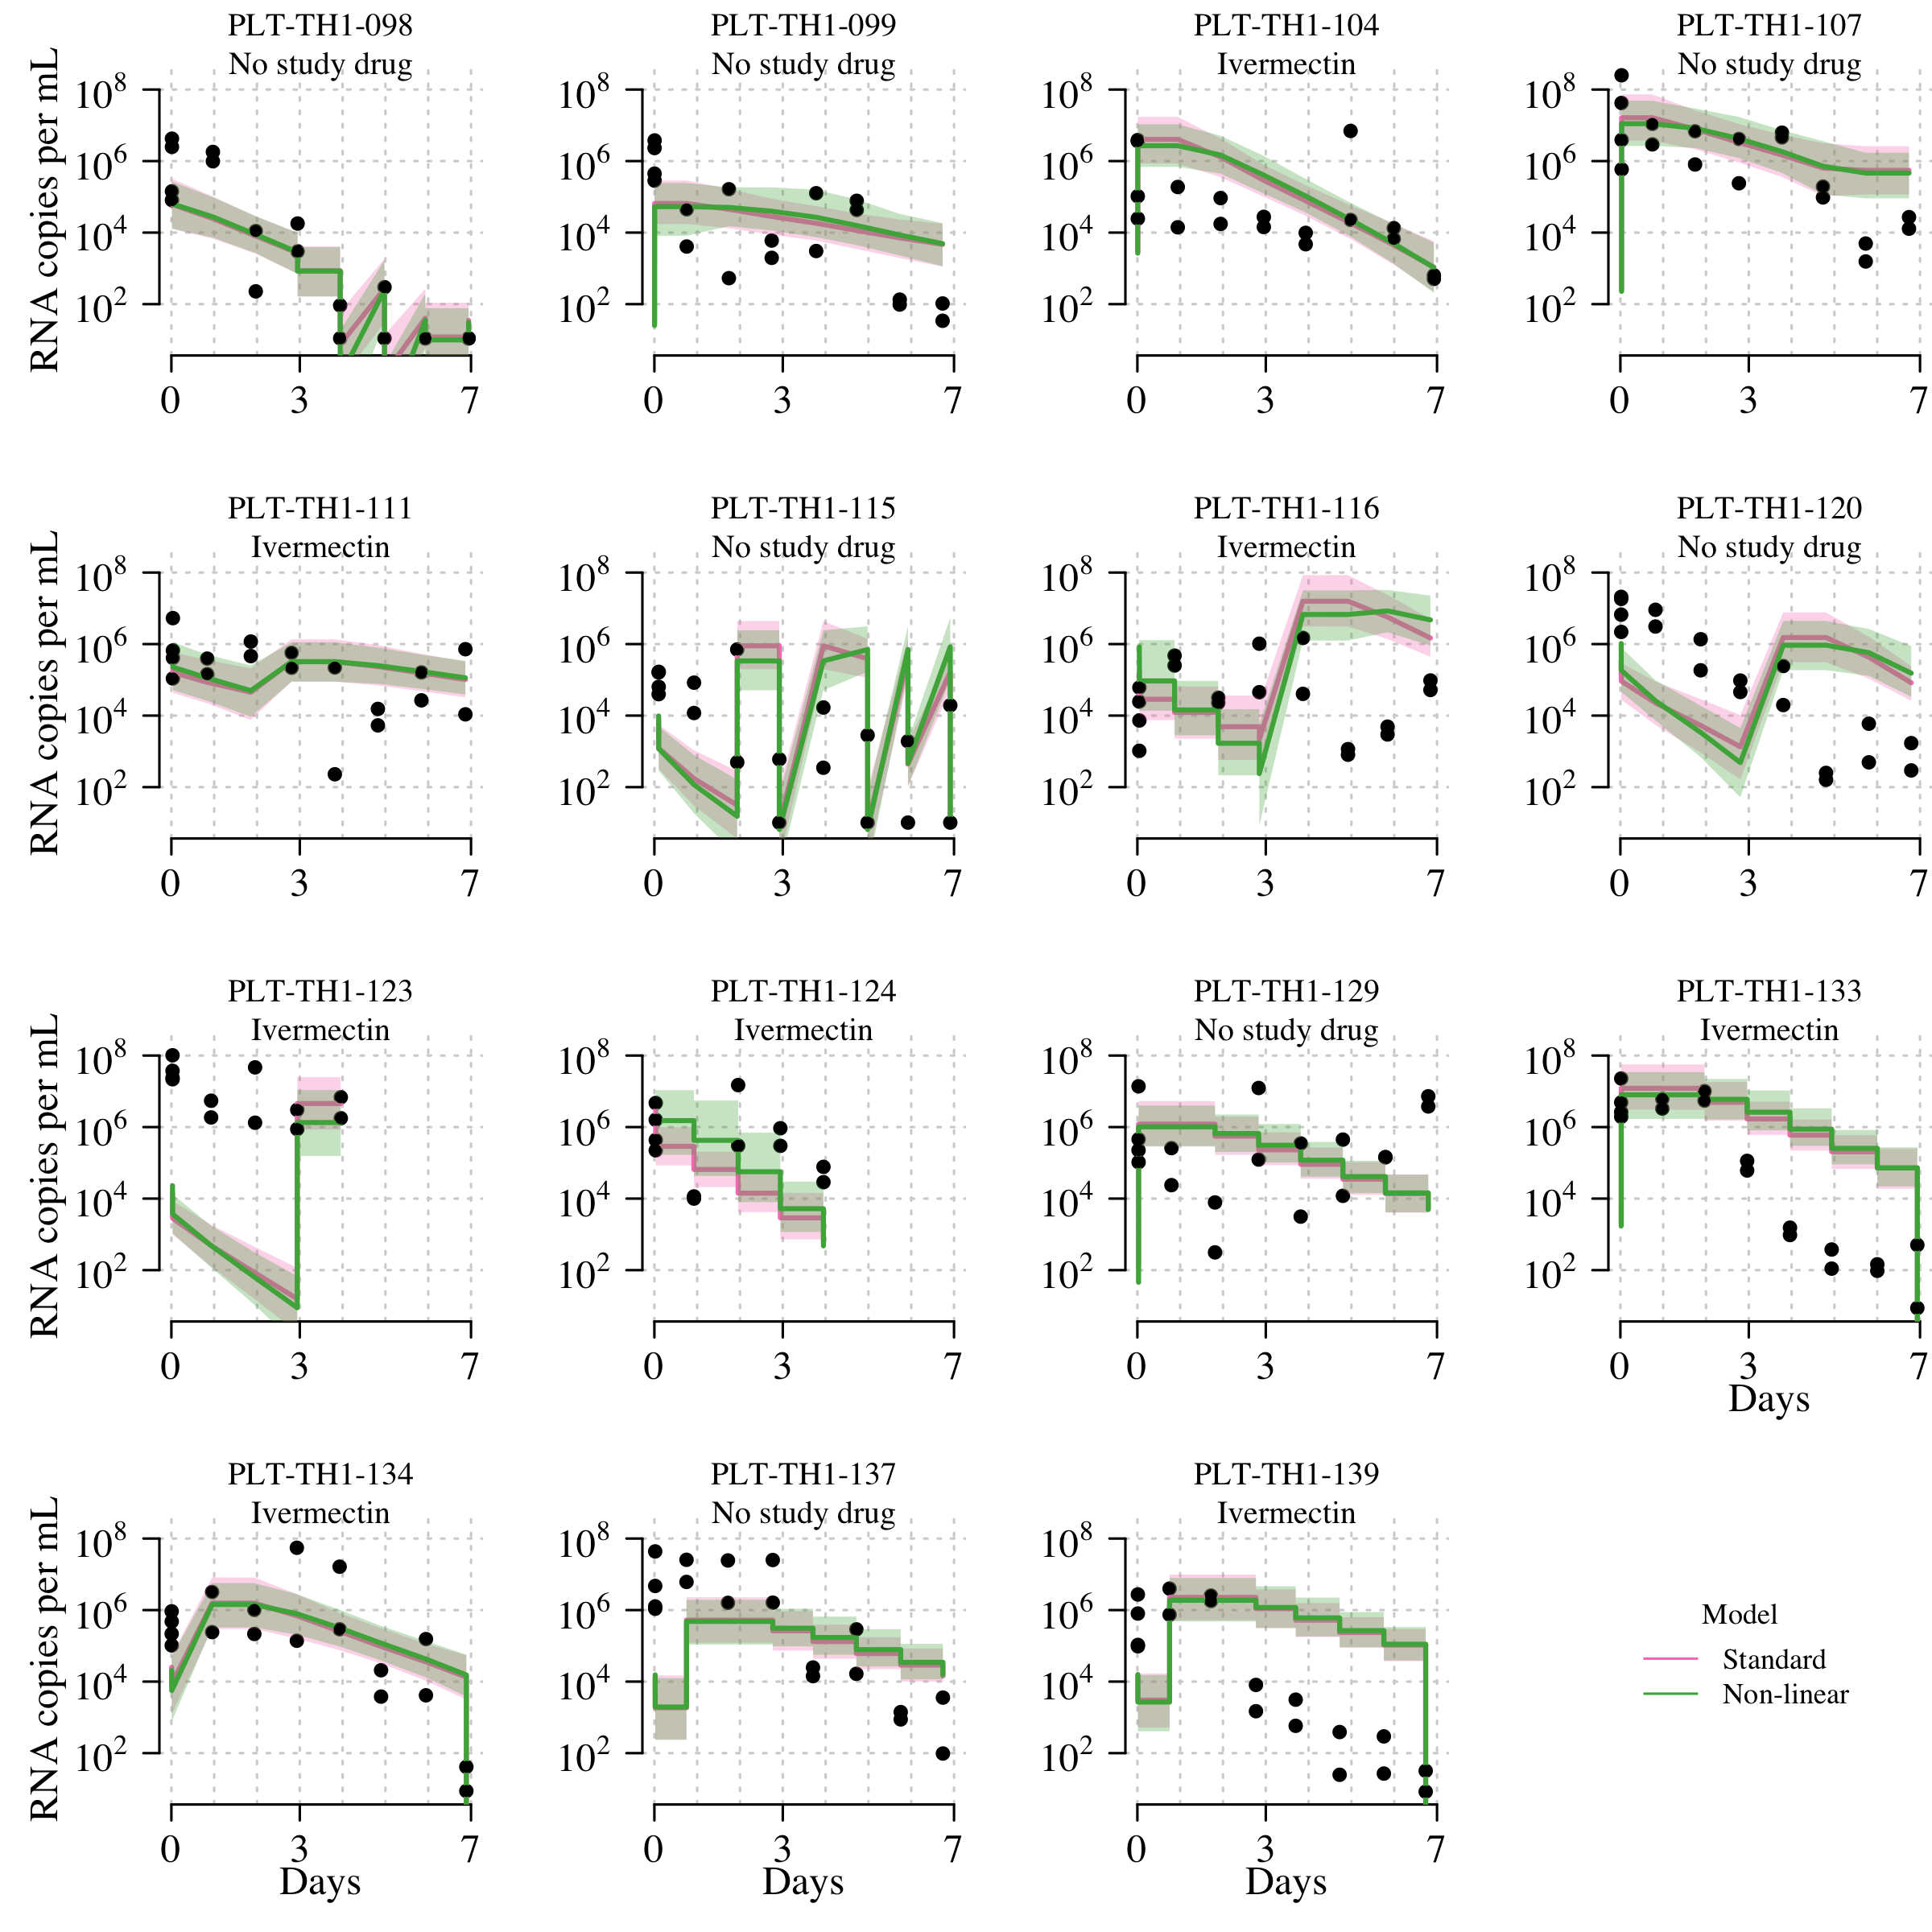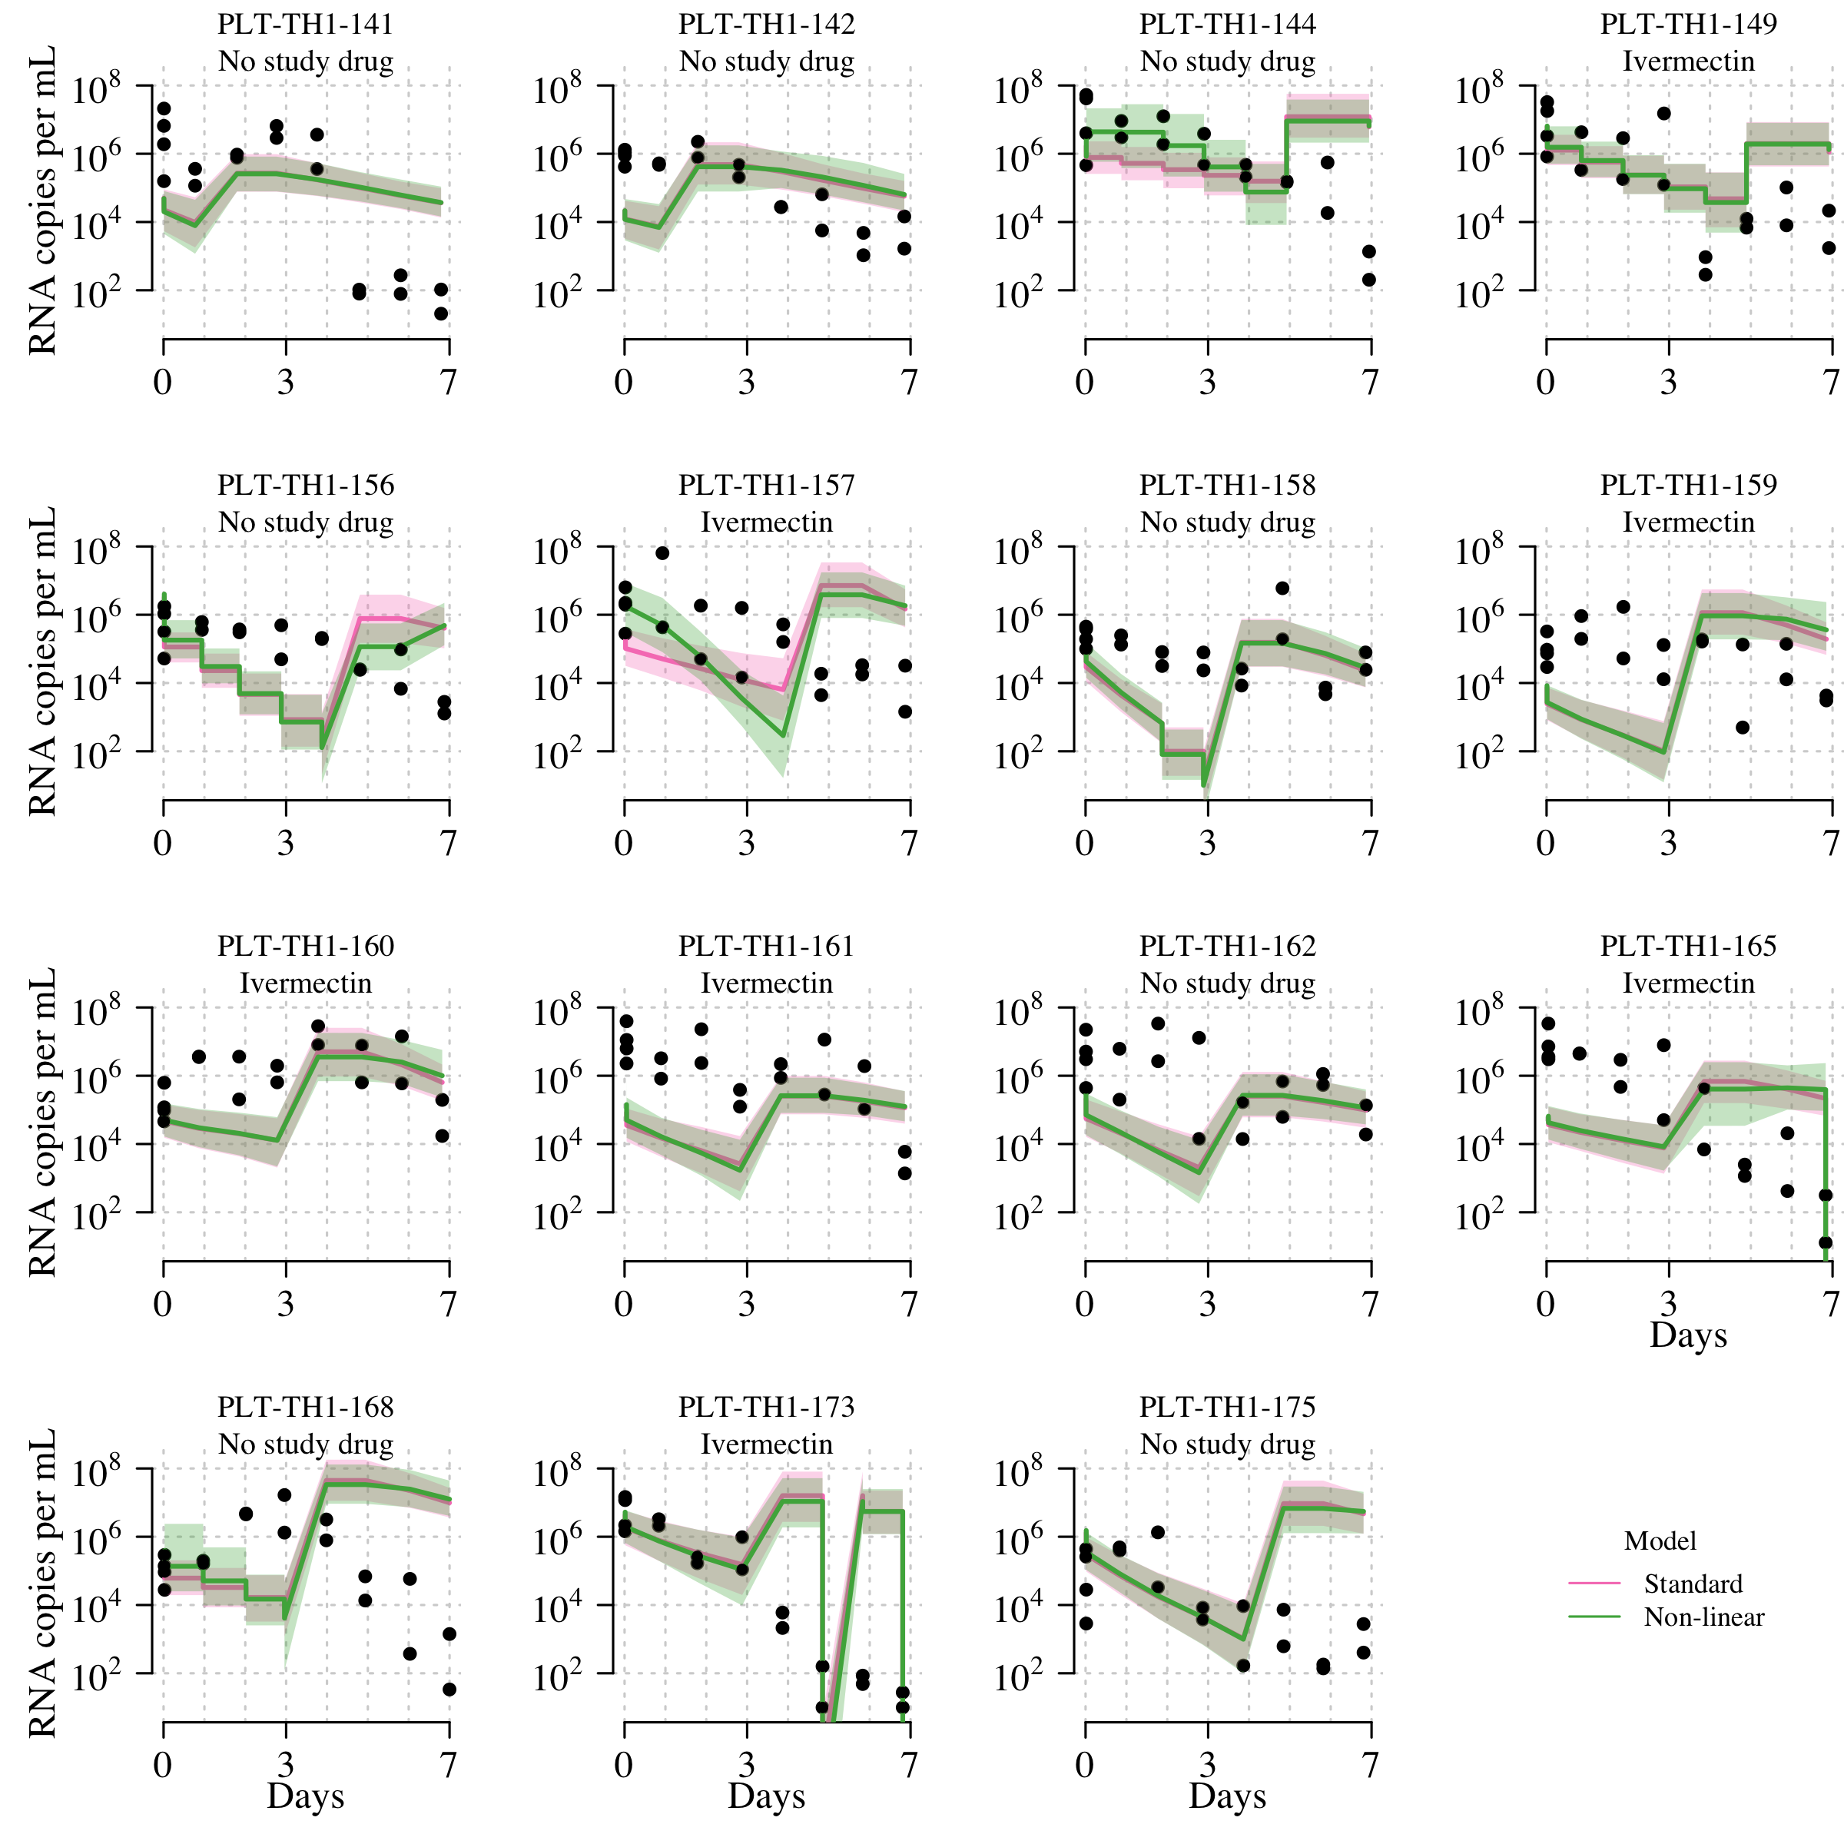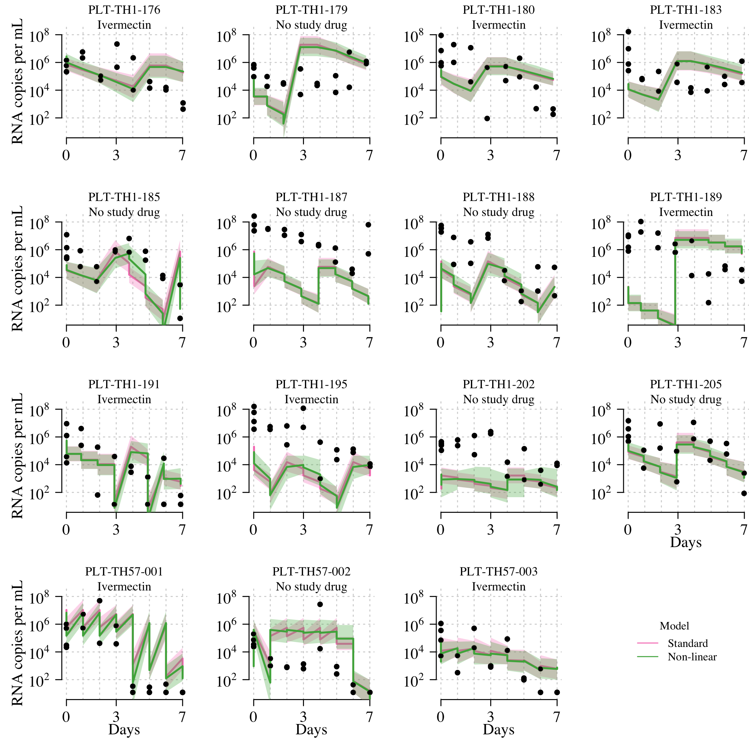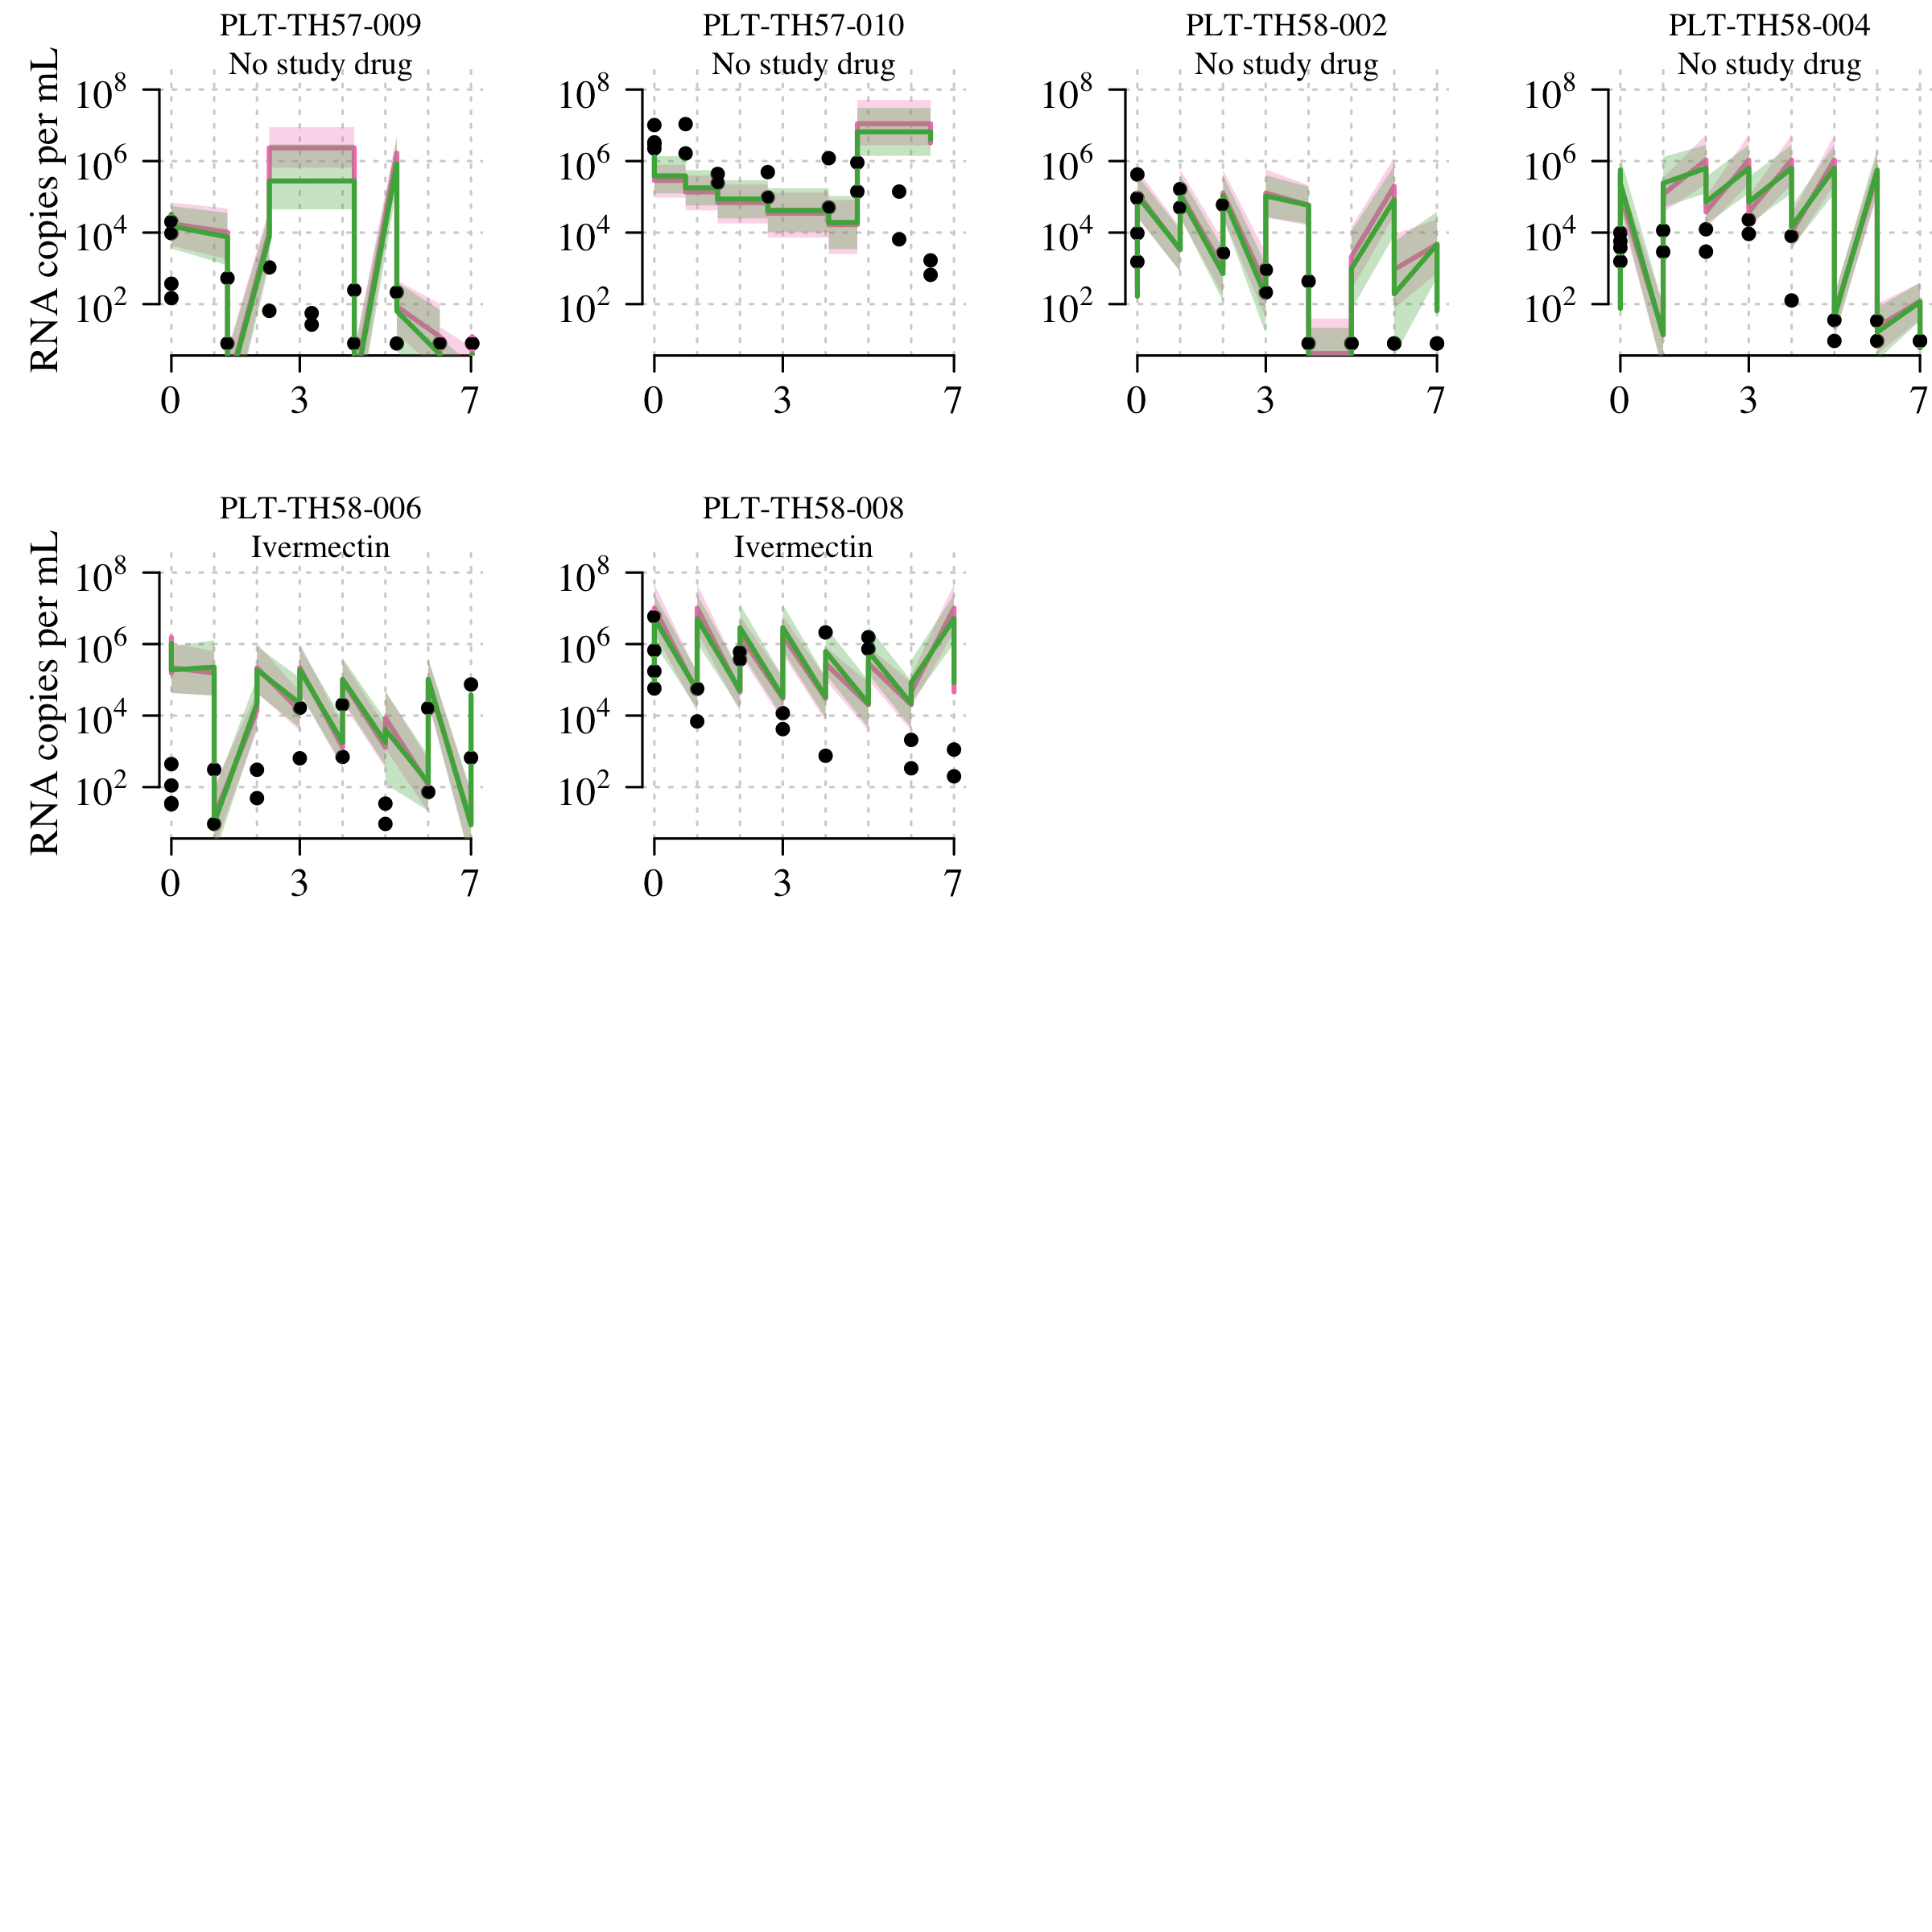

## Sensitivity analysis

### Treatment effects

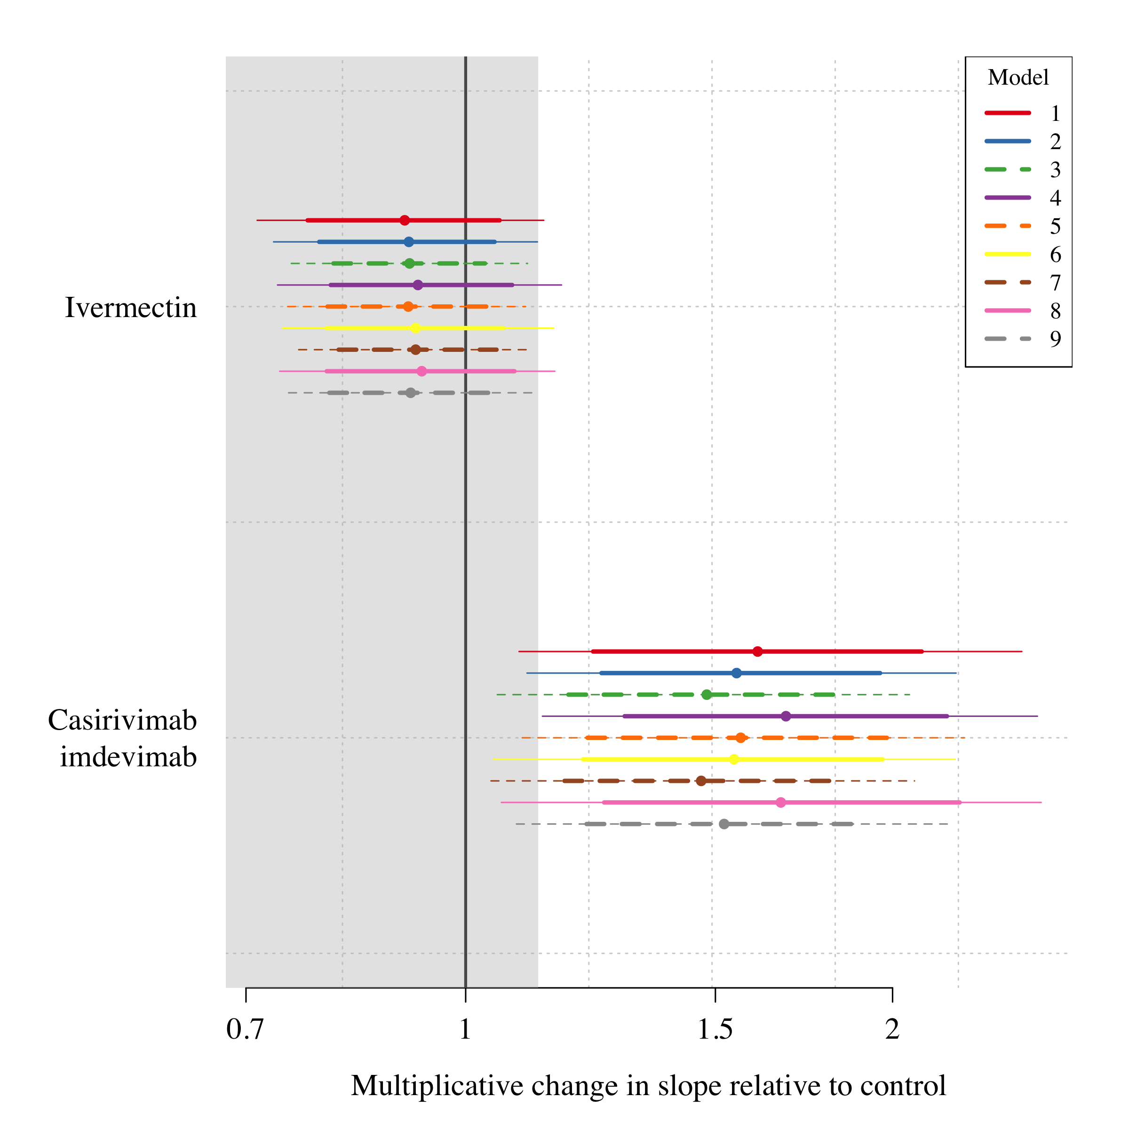

### Left vs right tonsil

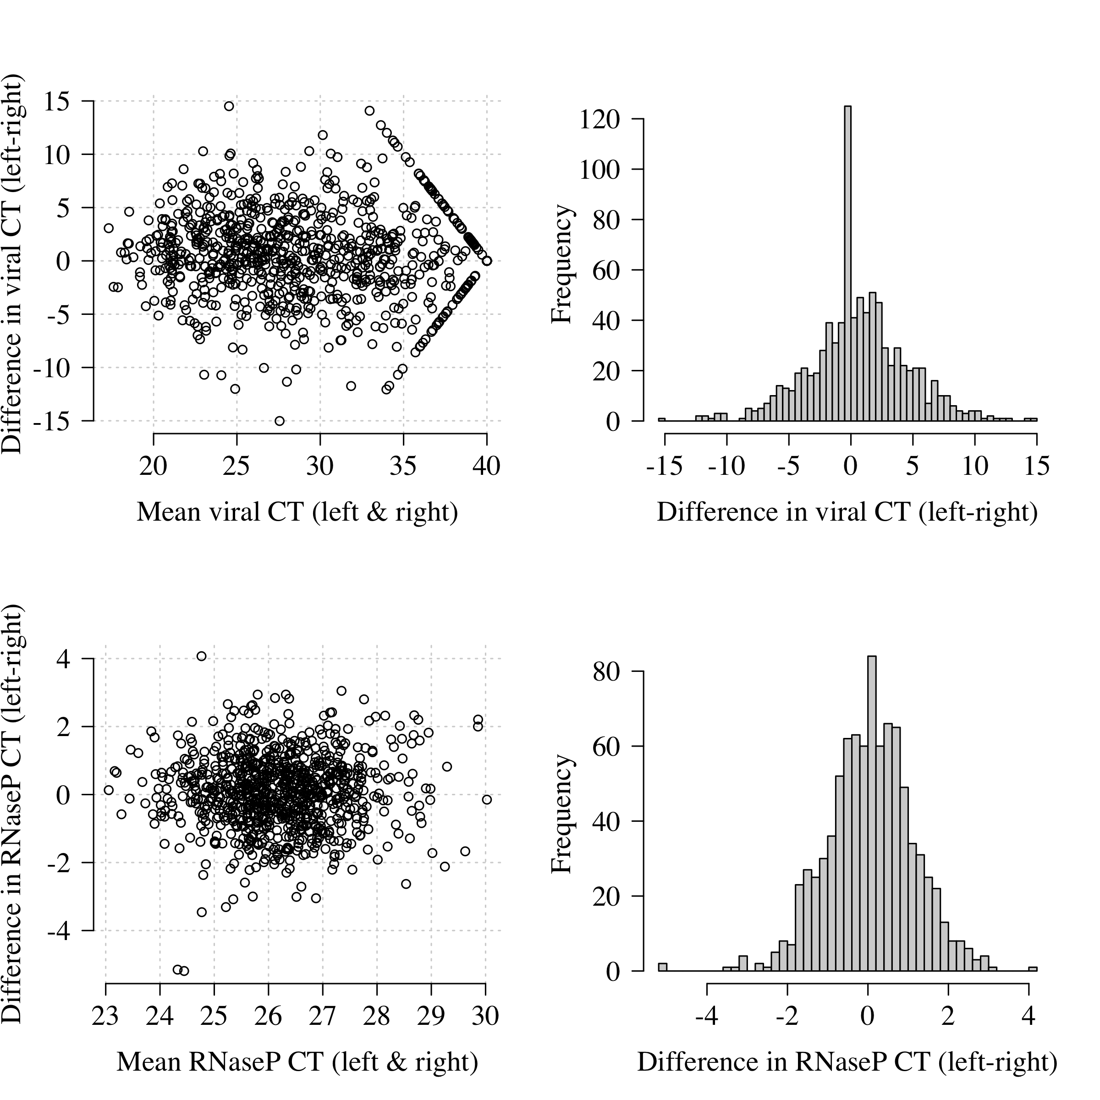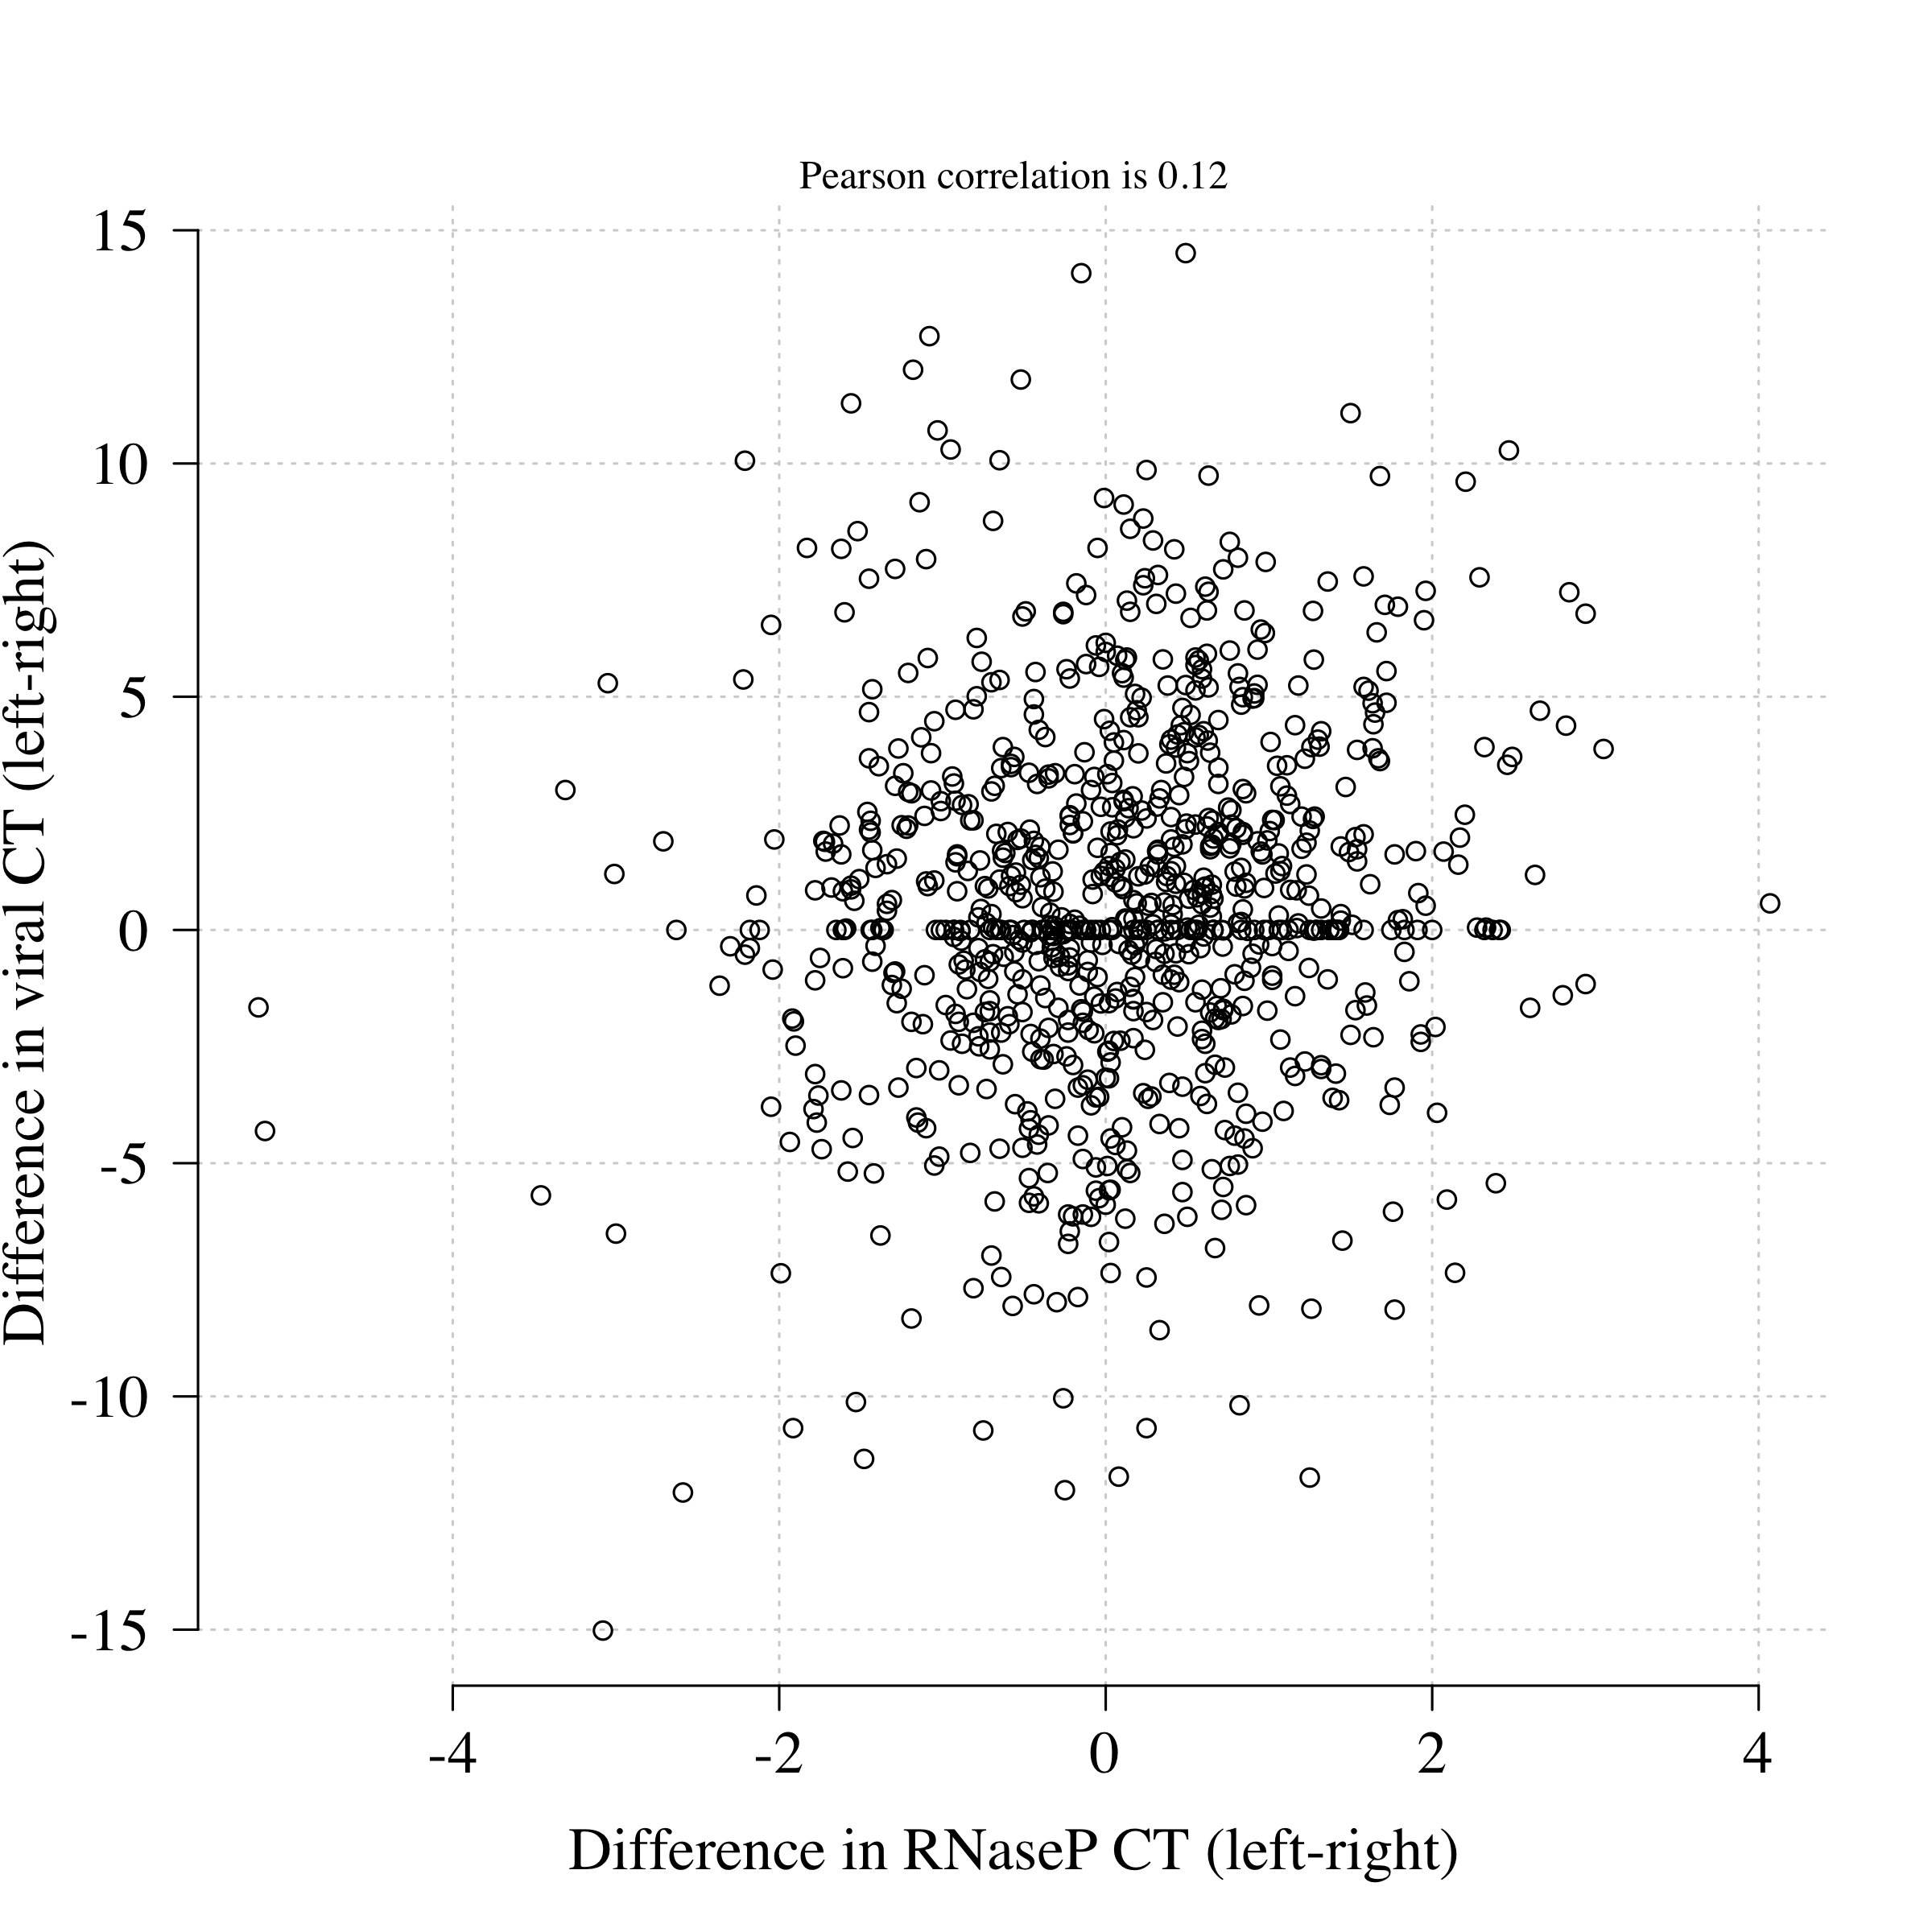

### Quality Control for PCR

## SD of the intercept is 0.93

## Maximum difference in CT values for a tenfold change in viral load is 0.69

